EDITORIAL BOARD

CHIEF EDITOR Dr. A. Balu. Principal.

Tamil Articles Dr. M. Suganthi

English Articles Mrs. V.Vidya

Drawing Mrs. E.M.N. Sharmila

TURNING THE PAGES

FROM THE PRINCIPAL’S DESK
TEN STEPS TO SUCCESS
AN INSIGHT INTO A COMMUNITY IN DARKNESS

EDUCATION IN LIFE
CRITERIA OF BEING SUCCESSFUL
JOKE WITH TEACHERS
INTERESTING ANECDOTES
A TIME WILL COME
GO GREEN
CIGARETTE SMOKE IS ONE OF THE WORST AIR POLUTION
HEALTH TIPS
PROCRASTINATION IS THIEF OF TIME
PRAISE
SEE LIFE WITH FUN
JOKES
SHAKESPEARE’S DEFINITION
SUCCESS
SECRET OF SUCCESS
LIFE
GOLDEN WORD OF DR.A.P.J.ABDUL KALAM
SHARPEN YOUR MIND
‘THE GREATEST’ IN LIFE
FASCINATING FACTS
SUCCESS
PARADOXES OF OUR TIME
CUTE RETORTS OF A TESTER
RIDDLES TO GIGGLES
TAKE TIME
ALPHABETS OF LIFE.....
PRESENCE OF MIND
DID YOU KNOW?
YOUR LIFE, YOUR CHOICE
WHAT IS LIFE?
FUNNY BUT TURE
ENRICH YOUR LIFE
YOUR LIFE, YOUR CHOICE
WISDOM EVER GREEN
FLOWERS SPEAK
HUMOROUS DEFINITION
POSITIVE THINKING
AS IT IS...
TEN SUPERLATIVES OF LIFE
FATHER’S DAY SPECIAL
BIOLOGY POEM
PLANTS
BOOST YOUR VOCABULARY

nghUslf;fk;
tWik
ngz;Nz..!
Vf;fk;
kPz;Lk; g+k;Gdy; itia
ntw;wpapd; tpspk;G!
el;G
epidj;jhNah?
rhgk;
fpWf;fy;fs;!!
Mrphpah;
Mrphpah;
X! ,isQNd...
ngz;
mk;kh!
rpe;jid...
Jzpr;ry;
ek;gpf;if...
fy;tp
Mrphpah;
,isQNd
md;idah; jpdk;
rpWfij
fUj;Jf;fs;
ntw;wp> Njhy;tp
jd;dk;gpf;if
gpioia jpUj;jyhk; thq;f!
Neh;kiw vz;zq;fs;
typikahd thh;j;ijfs;
tho;f;iff; fzf;F
mw;Gjkhd cz;ik
mk;kh...!!!
rhjidahsd;
tpl;Lf; nfhLj;jy;
nghWik
Kaw;rp
ifjl;ly;
tha;g;G
cah;e;j rpe;jid
jtW
jkpo;nkhop
ntw;wp
mg;Jy;fyhkpd; nghd;nkhopfs;
fw;Wf; nfhz;Nld;
tptrhap
ftpij
KJik
Ra Kd;Ndw;wk;
fUtpy; Rke;j jhNa…!!!
Njrg;gw;W ,d;W
From the Principal’s Desk ……
One of life’s simplest pleasures is having a nice cup of tea! Relaxing with tea rejuvenates the spirit and smoothes out the ruffled moments of a hectic day. Life offers much happiness and contentment if it contains the right mix of ingredients. More sugar and less milk or vice versa can lead to an unpleasant taste. Similarly, life has to be a proper mix of different ingredients like interpersonal relationships, health, career, finance, spirituality, etc.
Life is like a journey on a train … with its stations … with changes of routes … and with accidents! This train ride will be full of joy, sorrow, fantasy, expectations, hellos, goodbyes and farewells. Success consists of having a good relationship with all passengers … requiring that we give the best of ourselves. The bigger mystery of our life journey is we do not know when our last stop will come. Neither do we know when our travel companions will make their last stop. Not even those sitting on the seat next to us.
Therefore, enjoy your tea of life sipping it slowly and consciously living in the moment. Drinking your tea hastily might burn your mouth as does living a fast-paced life – it drains your spirit. Similarly, we must live in the best way – love, forgive, and offer the best of who we are. It is important to do this because when the time comes for us to step down and leave our seat empty from the train of life, we should leave behind beautiful memories for those who will continue to travel on the train of life.
So, live and let live!
Dr. A. Balu.
Principal.

TEN STEPS TO SUCCESS
Success is everybody's dream.. It is a beacon which lights our way. What is success ? We may have innumerable definitions of success. Still we feel that there is something elusive about success. It often exists beyond our full comprehension denying a clear perception. Success may mean different things to different people. People may use different standards for measuring success. What can be the criteria? Success? They vary from people to people. And sort of achievement is termed as sucess. Getting a job, making money, becoming famous etc are all considered successful feats. Is making money a success ? Then how do you account for Gandhiji's greatness? He led a whole nation for a noble cause. He was assassinated at the end. According to the worldly standards, we may call it as a failure. But it is not a failure. Again the case of Mother Terasa. The mother spent her life for others, for others, for the poor and sick was she wasting her life ?Were they examples of failures ? Why is it not so ?
It may be difficult to give a correct answer. Still we feel that there is definitely something noble about these lives. While they spent their life for others, they were making a real investment. We are inspired and enriched by their love and compassion. We cannot call them failures. They are ofcourse, successful personalities. What about the people who work hard in the fields and farms, but who donot have so much the liquid cash on their hands ? Do we call them successful ? Sure, if we can admire their great endurance and hard work, they are successful in our eyes. If they can get a sort of fulfillment out of their struggle , they are successful in their own eyes. They are ordinary people, but successful. We can see that success is a relative term. What some people term as seccess may not be success to others. Some who are considered failure may not be really failure. Success is what we feel for others and ourselves, and what others feel for themselves and us. Some men succeed by what they know ; some by what they do ; and a few by what they are . Ofcourse, we all want to be successful in life. Here are the TEN steps to reach to success.
1. FAITH IN GOD This the foundation of our success. The amount of energy that is getting through prayer and faith indispensible. Bring God to the centre of our life and make Him our Partner in our Business" -- says Normon Vincent.
2. FAITH IN FELLOW MEN We should have faith in our fellowmen and in the essential goodness of human beings. A sadist can never be successful in life. We have to trust in others. There may be a lot of evil around us. But our faith in the basic good-ness of people will definitely keep us on going.
3. FAITH IN OURSELF Faith in ourselves is essential for the development of our personality. We should be conscious of the power in us, the capabilities and inabilities we have. This faith in our self strengthens all our activities.
4. AMBITION
Life without ambition is dull. Ambition makes our life meaningful. But the ambition should not be determined to a point beyond our capacity.
5. OPTIMISM Healthy optimism is the key to action. Optimism makes miracles in ones life. An optimist will see an hope in a calamity and a pessimist will see only calamity.
6. VALUES A successful person is motivated by certain permanant values of life. Truth, goodness and Beauty are considered as the eternal values. These cannot be obtained by money
7. EFFORT Work is duty. When you devote your whole heart to the work you do, you ae happy. All success is due to hardwork. Do your Duty, that is your Beauty".
8. DETERMINATION Determination in trying out regular, systematic work is a quality which determines success. It is said that `great people are ordinary people, with extra - ordinary amount determination
9. INTEREST IN VARIOUS SUBJECTS A really successful person will have so many interests. eventhough he may be talented in a few Interest and knowledge of various subjects are very delightful.
10. CONCERN FOR OTHERS As human beings we are bound to keep a very soft corner for others in our heart. We are social beings. We cannot remain as isolate. By reaching for others we reach God, the centre of our life. Now, you have the goal in your mind. You have the blue print also. Now, what is needed more ? A tip of success is that "Before everything else, getting ready is the secret of 'success". I hope you are ready now to start for a successful life.
Dr.J.E. Merlin Sasikala
Assistant Professor

Ngdh
,jaj;jpd;
tha;
rpe;jidapd;
rpWJsp
cyfj;ijg; Gul;bg;NghLk;
nek;GNfhy;
fz;Zf;Fj; njupAk; gpuk;kh
NghHKid
VHKid
NgdhKid
ftdkha;
ifahsg;
gl Ntz;ba
$H Kid
Dr.M. Suganthi.
Assistant Professor
*********************************************************
An Insight into a Community in Darkness

Introduction
In India, we have achieved significant progress in the field of science and technology, agriculture, medicine etc. In spite of that, we have deprived communities like Narikuravar in Tamil Nadu, who are struggling for their rights to lead a socially enriched life with education, economic and social well-being. Narikuravars are widely known as nomadic communities having their own unique way of life and beliefs. The Narikuravas are an indigenous group of people, living in Tamil Nadu. The population of Narikuravar community is well below 30000 in Tamil Nadu. They have no representation in any decision-making bodies. Since hunting is prohibited they were forced to take up other alternatives such as selling beaded ornaments to survive.
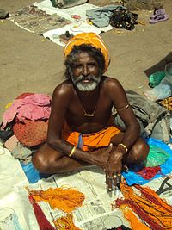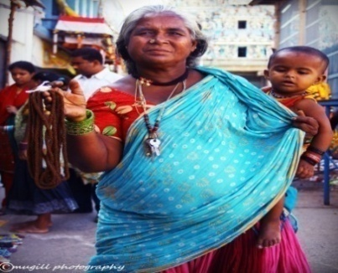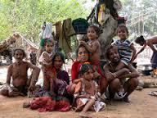
Language
The Narikuravas speak an Indo-Aryan language called Vagriboli. Vagriboli is a Western Indian language of the Indo-Aryan family. Due to this reason, they are also known as Vagris or Vagrivalas. Almost all Narikuravas are well-versed in Tamil.
Occupation and Living Conditions
As an ideal type, the nomads do not have a fixed home. They may have a story of their origin, the place where they lived before journeying eternally, but they do not have a place to which they return after travelling for some months in connection with their livelihood.

Discrimination
Owing to consumption of animals, places of settlement and other odd habits, they are classified as untouchables by caste Hindus. They are banned from using the streets inhabited by upper castes.
Illiteracy
In this age of Free education and Education for all, Education is still a mirage to the Narikuravar communities. It is no wonder that these communities are largely illiterate and a few educated ones have scrapped through only eighth standard
Child Marriage
Early marriage is a big threat to this community. 90% of the children get marriage before the age of 14 years. It denies the young an opportunity to grow and empower.
Included in ST Category – a Boon
Recent announcement of Central Government to include Narikuravar community in scheduled tribe category would light the lamp in their lives. This status has been achieved by this community through their long pending demand for over 35 years.
Welfare Measures
In 1996, a Social Welfare Organization named ‘NarikuravaSevaSangam’ was formed in order to educate Narikurava children and lead them towards a better life. In May 2008, a Welfare Board for the Narikuravas headed by the Backward Classes Minister was formed by the State Government with schemes for the minorities including marriage grant, educational loan, maternity loan, accident insurance, old age pension, etc. .But most of these people do not have the awareness about the scheme implemented by the welfare board.
Conclusion:
We live in an era of globalization, where every ethnic community is being recognized and acknowledged through its inclusion into the social mainstream.In this scenario the plight of the Narikuravar Community is very pathetic as they have been facing various kinds of discrimination; As a result, they are living in poor social condition. What we need is a committed strategic system of Social Welfare Administration to ensure that the Narikuravar Community has a focused intervention to uplift them from existing cycle of poverty and deprivation.

Dr. J.Jayachithra

Asst. Professor of Education
email: jayamadhav.chithra@gmail.com

EDUCATION IN LIFE
E -Enforces us to frame an enthusiastic life
D - Directs us to distinguish life
U - Uplifts us to understand life
C -Cheers us to make a cheerful life
A - Adopts us to an ambitious life
T - Tilts us to think about the life
I - Inclines us to improve our life
O - Organizes us to out face the obstacles in life
N - Nimbles us to navigate our life.
DR.G.RAJESHWARI
Assistant Professor.
**********************

Criteria of Being Successful
He has achieved success who has lived well,
Laughed often, and loved much;
Who has enjoyed the trust of pure women,
The respect of intelligent men and the love of little children;
Who has filled his alcove and accomplished his task,
Who has never lacked appreciation of Earth’s beauty or failed to express it;
Who has left the world better than he found it,
Whether an improved poppy, a perfect poem, or a rescued soul;
Who has always looked for the best in others and given them the best he had,
Whose life was an inspiration;
Whose memory a benediction.

V.Vidya
Teaching Assistant.

JOKE WITH TEACHERS
- Write an essay on milk. One boy wrote just four lines instead of a page. When asked the reason, he replied ,"Teacher, I wrote on condensed milk"
- Give reasons: "Heat moves faster than cold". One boy replied, "Because you can easily catch a cold and not a heat".
- S. NEELAVENI.
*****************************************

INTERESTING ANECDOTES
PRACTICE:
Paderwari had a weak musical memory. Therefore even at the height of his success, he had to practice from 8 to 10 hours a day. He said: "I can trustfully say that if I neglect my practice for one day, I can see the difference; if I neglect it for two days my critics discover it; and if I neglect my practice for three days, the whole world knows it.
BE ENLIGHTENED:
Socrates was in prison awaiting his execution. One day, he heard a fellow prisoner singing a difficult lyric by the poet Stesichorous. Socrates begged the man to teach him the lyric. "Why?" asked the singer. "SO I can die knowing one thing more, was the great man's reply. Hearing this story, a disciple asked his master, "Why learn something new one week before he died?" The master replied, "For exactly the same reason that you would learn something new fifty years before you die".
- S. NEELAVENI.
______________________________________________________
A TIME WILL COME
Once, the greatest Lord Melbourne, the Prime Minister of England asked a young man named Disraeli what he would like to be. Disraeli boldly replied, "PRIME MINISTER OF ENGLAND". Few men in world history present a more remarkable illustration of the ability to overcome hardship than Disraeli without opportunity. He struggled through the middle classes and the upper classes of his country. Three times he was defeated in parliamentary elections. When he made his first speech in the House of Commons, he was ridiculed, hissed, and jeered. He cried out, "The time will come when you will hear me.” And the time did come. He was determined with courage and confidence. He fought his way from the back benches of the House of Commons to leadership as " PRIME MINISTER OF THE BRITISH EMPIRE".
- S. NEELAVENI.
********************************************************
GO GREEN
One of the biggest crises faced by our planet in 'GLOBAL WARMING'. Therefore, plant a saplings whenever and wherever you can. Spend part of your energy and least of your time for growing trees.
Keep a ride for a while your mobile phones and whatever that keeps you connected. Stop availing those wonderful sms for a while.
Let not boredom force you to grab your mobile phones and talk non- stop about someone, something or anything from which you gain nothing but a momentary enticement.
Watch a sapling grow, and you experience the fullness of life. You sure will fly through life as butterflies, feeling full.
We spend endless hour on the mobile phones for fun, gossip and romance but think twice to go out on the street, dig a pit and grow a plant.
Do it right away. Every time you feel the urge to including in gossiping, just go and water the sapling. Make a conscious decision to plant trees, even though you may not sit under them.

- J. ARUN PRAKASH
********************************************************
CIGARETTE SMOKE IS ONE OF THE WORST AIR POLLUTION
- Over 1 million people start smoking every year.
- Cigarette smoking kills about 350,000 people every year in the United States alone.
- Cigarette smoke contains 4,000 different chemicals.
- Each cigarette smoked subtracts about five minutes from life expectancy.
HEALTH TIPS
- Normal Blood Pressure - 120/80
- Normal Blood Sugar Level -120- 80
- Normal Heart Rate Per Minute - 80 -60
- mg- Normal Cholesterol Level -200
- Ideal Body Mass Index (weight / height) - 25-20
- Minutes of exercise needed per week - 150
- Litres of water required per day - 3 -2
- Number of sleeping hours daily - 9-7
- K.VIJI
********************************************************
PROCRASTINATION IS THIEF OF TIME
Do not Postpone your works for tomorrow
Tomorrow will have its own works.
Do not be reluctant to give wages to your servants
They too have their own emergencies.
You cannot build today by utilizing tomorrow
Time is money, chances come seldom, don’t miss it.

There is no tomorrow to build a better world.
Yesterday is dead, tomorrow is to be born,
‘So, live today’.
C.JOTHIMANI

PRAISE
Praise the night,
For your being has been there.
Praise the darkness,
For you don’t know the light without it.
Praise the pain,
For without it pleasure is meaningless.
Praise the eclipse,
For it alone can bring you the full moon.
Praise the summer,
For if it’s not there, we miss the joy of rain.
Praise the neighbour,
For he tells you that no one is an island.
Praise the failure,
For it tells you how ‘that way’ does not work.
Praise the death,
For it gives a breakthrough to life eternal.
Praise the step taken,
For you know not the life-turning step ahead without it.
Praise for not having talents,
But be grateful for not having defects.
Praise the sin,
For you will remain ignorant of what sacredness means without it,
“Never curse the imperfection while you long for perfection”
C.JOTHIMANI
**********************************************************
SEE LIFE WITH FUN
Conference: A meeting of bored people.
Cheque book: A book with an unhappy ending.
Prices: The only thing which violates the law of gravity.
Life: Is a cigarette which begins with flashes but ends with ashes.
Politician: One who shakes your hand before elections and your confidence afterwards.
Diplomat: A person who thinks twice before saying nothing.
Optimist: A person who lights a match before asking you for a cigarette.
Dentist: A person who always believes in hand to mouth existence.
Exams: Where the foolish ask questions which the wise cannot answer.
- M.SIVASANKARI
********************************************************

JOKES
Ravi: Why is the computer never hungry?
John: Because it has enough ‘Bytes’.
***************
Teacher: Why are you late to class?
Pupil: Because of a road sign I have to pass on the way.
Teacher: And what has the sign got to do with it?
Pupil: Why, it says: school ahead, go slow.
*****************
Husband: Why are you crying, Sonia?
Wife: I read a book with a sad ending.
Husband: Which book?
Wife: Your bank passbook.
************
Father: Youngman, I understand, you seem to be interested in marrying my daughter.
Youngman: Yes sir. I am a marriage broker.
- M.SIVASANKARI

SHAKESPEARE’S DEFINITION.......
Life is not a TEMPEST
Nor is it a MID-SUMMER NIGHT’S DREAM.
It is more like a COMEDY OF ERRORS
And there is MUCH ADO ABOUT NOTHING.
You can’t be like ROMEO AND JULIET
And die on the TWELVETH NIGHT.
You may live like the MERCHANT OF VENICE
And call yourself CLEOPATRA OR KING LEAR.
But you will be happy only when
You live “AS YOU LIKE IT”.
- M.SIVASANKARI
--------------------------------------------------------------------------------------
SUCCESS
S - See your goal
U - Understand the obstacles
C - Clear your doubts
C - Create positive picture
E - Embrace the challenges
S - Stay on track
S - Shine in your future
- M.SIVASANKARI

SECRET OF SUCCESS
“Aim high” says the sky,
“Think deep” says the clock,
“Keep shining” says the star,
“Keep cool” says the cucumber,
“Be faithful” says the dog,
“Be disciplined” says the art,
“Never give up” says the spider,
“Be sharp” says the crystal,
“Remain hopeful” says the bird,
“Reflect the truth” says the rainbow,
“Be gentle” says the breeze,
These are the little keys for a successful life.
- M.SIVASANKARI
******************************************
LIFE
Life is like a camera
Face it with a smile always.
Life is like a film
Which includes both tragedy and comedy.
Life is like a bed of roses but
Painful thorns.
Life is like an ice cream,
Taste it before it melts.
Life is like maths
It has many problems.
Try to solve them.
Life is a teacher,
Who teaches us everything
For the future.
- M.SIVASANKARI

GOLDEN WORDS OF ABDUL KALAM
Character:
Even a big pot full of water will be emptied by a small hole. Likewise just a little anger or ego will burn the nobility of character!
Beauty:
I am not handsome but I can give my HAND TO SOME. One who needs help. Beauty is in heart not in face.
Luck:
Luck is not in your hands but work is in your hands. Your work can make luck but can’t make your work.
Voice:
Never raise your voice, just improve the quality of your argument!
Success:
When your “SIGNATURE”
Changes to “AUTOGRAPH”
That is Success.
YOUR BEST TEACHER IS YOUR LAST MISTAKE.
- M.SIVASANKARI
**************************************
SHARPEN YOUR MIND
- Two fathers took their sons fishing. Each father and son caught one fish. But when they returned to camp there were only 3 fish. How could this be? (None of the fish were eaten, lost or thrown back)
- There are five squares (one 3*3 and four 1*1) formed with 20 matchsticks, as shown in the illustration. Move two matchsticks to get seven squares. Overlapping or breaking of matchsticks or ‘loose ends’ are not allowed.

Solutions:
- There were only three people. The son, his father and his grandfather.
- Seven squares are formed. Five 1*1 squares, one 2*2 square and one 3*3 square.

C.SARANYA
********************************************************
‘THE GREATEST’ IN LIFE
The greatest mystery - Death
The greatest gift - Life
The greatest work - What you love doing
The greatest feeling - Happiness
The greatest sorrow - A broken
The greatest criminal - A liar
The greatest thought - “I can”
The greatest want - Acceptance
The greatest need - Awareness
The greatest waste - Hatred
The greatest asset - Your mind
The greatest tool - Your body
The greatest sense - Touch
The greatest relationship - Long-term friendship
The greatest bankruptcy - Lack of confidence
The greatest mistake - Quitting
The greatest moment - Now
The greatest bore - Repetition
The greatest trick - Proving the impossible to be possible
C.SARANYA
***************************************

FASCINATING FACTS
- The world’s most popular hobby is stamp collection.
- One tonne of uranium produces the same amount of energy as 30,000 tonnes of coal.
- The largest magnet in the world is the earth itself, because the hot nickel and iron at its core pull everything towards it.
- No solar eclipse can last longer than 7 min 58 sec because of the speed at which the sun moves.
- Tomatoes were originally called “love apples”.
- The most talkative parrot on record, an African grey parrot belonging to a London family, had a vocabulary of almost 1000 words.
- The lion has the smallest heart of all beasts of prey.
- A Zebra’s stripes are as individual as human finger prints. No two zebras are striped alike.
- The humming bird can fly backward, sideways, forward and hover motionless for up to an hour.
- The lead in the average pencil will draw a line 35 miles long.
- The muscles of the human jaw exert a force of over 219kg.
- One fifth of the oxygen we inhale is used up by the cells in the brain.
- The floating Island of lake ALM in upper Australia moves constantly from shore to shore.
- RG.ASWINIKRISHNAM
--------------------------------------------------------------------------
SUCCESS
Success doesn't mean you have succeeded forever,
It does mean you have won a battle and not a war.
Success doesn't mean you have gained everything,
It does mean you have earned a penny but not a dollar.
Success doesn’t mean you are the wisest person,
It does mean you have become one among the scholar.
Success doesn't mean you own it permanently,
It does mean that it could go into others’ hands anytime quickly.
Success doesn't mean you are superior,
It does mean you should be meek and humble.
Success doesn't mean you are the winner forever,
It does mean your place could be easily replaced.
Success doesn't mean you have achieved something,
It does mean you should retain your place by working harder.
- S.SUBHASHINI
*************************************************
PARADOXES OF OUR TIME
Taller buildings, Shorter tempers
Bigger houses, Smaller families.
More conveniences, Less time.
More degrees, Less sense
More knowledge, Less judgment
More experts, Less solutions.
Huge incomes, Lower morale.
Big profits, Shallow relationships.
Variety of food, Less nutrition.
Strong houses, Broken homes.
We have learned how to make a living, but not a life.
We have larger things, but not better things.
- B. DHIVYA
______________________________________________________

CUTE RETORTS OF A TESTER
Question: With the cost of living going higher every day, can you
suggest any method of saving electricity bills? Answer: Yes, paste them in a scrap books.
Question: Is it bad luck to postpone a wedding! Answer: Not if you postpone it indefinitely!
Question: What is the best thing to do when the barkers of one's car
fail?
Answer: Hit against something cheap!
Question: Do you think a husband should have a voice in furnishing
the home?
Answer: Well, he usually does-the invoice!
Question: I have taken up gardening as a hobby. How can I
distinguish a flower from a weed!
Answer: Cut them all down. The ones that come up again are
weeds.
Question: Why do we call our language the Mother Tongue!
Answer: Because father never gets a chance to use it!
- B. DHIVYA

RIDDLES TO GIGGLES
What do you call a baby that is having a nap?
Kidnapper
How do you call a letter that comes through Chimney?
Blackmail
What is the best way of getting the first prize in a race?
Just run faster than the rest.
What is the name of the bull that is sleeping?
Bulldozer
What is that comes down that has never gone up?
Rain
Why do they build a strong wall around the cemetery?
Because people are prepared even to die to get in there.
- K.PUSHPAKALARANI
TAKE TIME
Take time to play
To maintain your body fit.
Take time to read
To extend your knowledge.
Take time to speak to your kith and kin
To develop your relationship.
Take time to sleep
To make you fresh.
Take time to think
To know about yourself.
Take time to listen to music
To make you feel free,
Take time to write
To expose your inner feelings,
Take time to do those things
That make you best.
- K.PUSHPAKALARANI
ALPHABETS OF LIFE...
Always try to have a smile ...
Be ready to help others and be ...
Careful with your choice of words ...
Decide your goals in life and make yourself ...
Eligible to attain those goals ...
Face the obstacles boldly and try to ...
Guide your fellow – being towards their goals ...
Have a heart filled with confidence ...
If not today, you will shine tomorrow ...
Just keep on working towards your plan and have a ...
Keen interest on things which you are doing ...
Live your life to the fullest because any ...
Moment could turn into a precious memory ...
Never say no to any chances, as ...
Opportunities knock our door only once ...
People criticize on everything you do but don’t ...
Quit today because you might win tomorrow and they are ...
Ready to help you on their shoulders ...
Success is not measured by quantity but by quality ...
Truth never dies and it should be your ...
Ultimate companion throughout your journey of life ...
Victory will come only to those ...
With courage and have faith in god, so that ...
X or Y may not find fault in you. And have a ...
Zeal to give your best on everything.
- R. JANANIBALA

PRESENCE OF MIND
People know well about how to use their presence of minds. But few of them are really using their intelligence at right time. This story is about one such man.
Albert Einstein was travelling to universities, giving lectures on the famous theory of relativity. One day, he got sick, so, his driver asked him to take rest. But, Einstein refused to do so, as he had accepted to give lecture on that day. Then the driver said, “Dr Einstein, I have learned it by heart and bet I could give it myself?
“Well, I’ll give you the chance,’’ said Einstein, “They don’t know at the next school, so when we get there , I’ll put on your cap and you introduce yourself as me and give the lecture.’’
The driver gave Einstein’s lecture so wonderfully that he didn’t make any mistakes.
When he finished, he started to leave, but one of the professors stopped him and asked him a question which was very difficult. The driver thought fast and said, ‘The answer to that problem is so simple and I’m surprised you have asked it to me. In fact to show you just how simple it is, I’m going to ask my driver to come up here and answer your question.” And he gave the mike to Einstein.
This is what people call as ‘presence of mind’.

- R. JANANIBALA
********************************************
DID YOU KNOW
Why does pepper make you sneeze?
A sneeze is a reflex that is triggered when nerves ending inside the mucous membrane of the nose are stimulated. Pepper, be it white, black or green, contains an alkaloid of pyridine called piperine. Piperine acts as an irritant if it gets into the nose. It stimulates the nerve ending inside the mucous membrane. This stimulation will cause you to sneeze. Actually, the nose wants to kick out this irritant and the only way it knows how to do this is by sneezing.
How do 3D movies work?
3D movies are created by a combination of cinematography and optics ; in effect , they are optical illusions. The majority of the 3D films are actually two films playing at the same time each one has been designed so it’s meant to eye. The 3D glasses you wear filter those image, making sure they are interpreted correctly by your optical sensor . Your eyes and brain naturally combine two images into one. It’s the basic principle of sight. When this happens with the two images from a 3D film, you get a layered optical illusion that creates three – dimensional depth.
-V.Yamini

YOUR LIFE, YOUR CHOICE
Wish not that life was easier.
Wish not that you were luckier.
Wish not that you were someone else.
Wish not that your kids were better behaved.
Wish not that you had a bigger car or house.
Wish not that work was more rewarding.
Wish not that you had less stress in your life.
Wish not that you were more comfortable or secure.
Wish not for any of those things.
Wish that you were better!
- V. YAMINI
*****************************************************
WHAT IS LIFE
Oh life! Some laugh, others cry.
I surely keep things in secret and remain dry.
Many have likes and live for fame.
But, if you define a meaningful part
Some fail even though they try.
You have chance in equal with all in the strife
It’s worth to accept you with equal pleasure
A courage to strive and to dare.
You’re a gift of god to human race,
With my faith and honor held high;
How great is good almighty
At last, All things well but; everywhere in chains.
- S.SUBHASHINI
**********************************************
FUNNY BUT TRUE
1, If your eyes are positive, you will like all the people in the world. But, if your tongue is positive, all the people in the world will like you.
2, It’s very easy to hurt someone and then say ‘sorry’. But, it’s really very difficult to get hurt and say, “I’m fine.”
3, For a boy it is easier to pick up a girl of weight 45 kg . But, it is quite difficult to pick up a gas cylinder of weight 14.2 kg.
4, Time makes us forget some people, but some people make us forget time. Such people become our life.
5, Sometimes small things in life hurt a lot . If you do not agree with this fact, try to sit on a pin!
6, Call a girl pretty and she will remember it for five minutes. Call a girl ugly and she will remember it forever.
7, Sometimes mobile phones do not get you close to people. It just takes you away from the ones sitting next to you.
8, Everybody tells, mistakes is the first step to success .but it is not true. The correction of mistake is the first step to success.
- S.SUBHASHINI
===========================================
ENRICH YOUR LIFE
Ways of giving:
There are five ways to give :
- The careless way: To give something to every cause that is presented without inquiring into its merits.
- The impulsive way: To give from impulse - as much and often as love and pity and sensibility prompt.
- The lazy way: To make a special offer to earn money for worthy projects by fair, bazzars etc...
- The systematic way : To lay aside as an offering to god a definite portion of our gains - one tenth, one fifth, one third or one half (rich or poor can follow this plan).
- The equal way: To give god and the needy just as much as we spend on ourselves.
- A.MANIKAVALLI

YOUR LIFE, YOUR CHOICE
We have a choice - everyday - regarding
The attitude we will embrace for that day.
We have a choice - every minute - regarding
The action we will do for that minute.
We have a choice – every second - regarding
The choice we will make for that precious second
So,
When you start your day, keep three words in the pocket
TRY - TRUE - TRUST
TRY for better future.
TRUE with your work.
TRUST in god.
- A.MANIKAVALLI
******************************************************
WISDOM EVERGREEN
- The one - eyed man does not thank god until he sees a blind man.
- Never mind if your nose is ugly as long as you can breathe through it.
- Quarrels end, but words once spoken never die.
- The ruin of a nation begins in the homes of its people.
A creature is not greater than its creator.
- A Strength of the crocodile is the water.
- A.MANIKAVALLI
-------------------------------------------------------------------------------------------
FLOWERS SPEAK
Flowers....
Tell of the marvels of god
Flowers, so fragile and yet beautiful.
SPEAK OF LIFE:
Life that is fragile
It is made of flesh and blood
Life that is beautiful, God’s gracious gift
Flowers, so colorful and fragrant
Joy of life, Joy of friendship, of a achievement of
relationship.
SPEAK OF HUMANITY:
Flowers, yes they tell of life and death
Two significant moments....
Flowers invite us, remind us
We have one earth ...
Living, sharing, loving!
- K.SARANYA.

HUMOROUS DEFINITION
BARGAIN:
Usually something that’s so reasonable they won’t take when you find out what’s wrong with it.
MIDDLE AGE:
When you want to see how long your car will last instead of how fast it will go.
OPTIMIST:
A fisherman who takes a camera with him when he goes fishing.
PSYCHIATRIST:
Someone who, when a pretty woman enters the room, watches everyone else.
INFLATION:
Inflation is when you can’t have your cake; dieting is when you can’t eat it.
EXECUTIVE:
A person who talks golf in the office and business on the golf course.
PREJUDICE:
A great time-saver that enables one to form opinions without bothering to get the facts.
- K.SARANYA.
POSITIVE THINKING
Embrace the things that make you happy,
Not the things that make you sad;
Consider the fine and true in humankind,
Not it’s sordid sad and bad;
Feel the blessings that surround you,
Not the ones that are denied;
Thank for the virtues of your friendships,
Not the weak and faulty side;
Keep the good of you that’s spoken,
Not some cruel, hostile word;
Imagine the days of health and pleasure,
Not the days of woe and pain;
Hold the treasures you have gathered,
Not the ones you’ve failed to find;
Think of the happiness of others,
And in this you’ll find your own!
- Dayana Mercy

AS IT IS...
Life goes on, for both cowards and heroes,
One day, it seems to have only hurdles and chaos;
Next day it holds more joy and pleasure,
It is full of secrets and one can’t assure;
What will happen in the Future,
Men should learn to act mature;
As life has to be accepted as it is ...
- A.DAYANA MERCY
********************************************
TEN SUPERLATIVES OF LIFE!
Good health is the man’s GREATEST fortune.
Disrespect towards one’s parents is the man’s WORST crime.
Taking drugs is the man’s GREATEST foolishness.
Arrogance is the man’s GREATEST failing.
Progress is the man at his MOST ADMIRABLE.
Forgiveness is the man’s GREATEST present.
To bully people is the MOST DESPICABLE act.
Gambling is the man’s WORST case of bankruptcy.
Helping a person is the man’s GREATEST happiness.
- M.PRIYANKA
FATHER’S DAY SPECIAL
DADDY KNOWS
How many months have you waited for me?
How many miles have you walked for me?
How many days have you worried long?
How many years have you filled with joy?
Nobody knows but you, DADDY.
How many times have I hurt your heart?
How many times have we had to part?
How many prayers have you said for me?
How many sacrifices have you done for me?
Nobody knows but you, DADDY.
How many times will your heart be glad?
How many times will you say of your daughter?
“I know she’d repay me for all of my sacrifices?
I know my effort would not be in vain?”
Nobody knows but you, DADDY.
And so we’re giving this day to you;
Thou the hours are short and the minutes few,
That you may know this sacred day,
We are thinking of you, and pray,
Nobody knows but you, DADDY.
HAPPY FATHER’S DAY.
- M.PRIYANKA
********************************************************
BIOLOGY POEM
Oh, cell
Oh, cell
How I love thee,
Your cell remembarance holds me together whenever I feel like falling
apart.
The MITOCHONDRIA which you contain gives me the energy to go on.
My feelings are given to me by your ENDOPLASMIC REDICULUM
Which is what?
I love about you.
The most important thing which allows me to love you
Is your heart
Your Nucleus is the heart which I will always love.
Oh, cell
Oh, cell
These are just a few reasons why you are a major part of my life.
- M.PRIYANKA
PLANTS
Plants are green
Leafy and thorny
Air, water, sunlight, they need
Nice Flowers, Fruits and Vegetables they give.
Trees, shrubs and grass
Soil is where they grow.
- R.KARTHIK

BOOST YOUR VOCABULARY
BRITISH ENGLISH | AMERICAN ENGLISH
Petrol Bunk | Gas station
Highway | Express way
Rail road | Railway
Trousers | Pants
Wire | Telegram
Bus stand | Bus station
Rail carriage | Rail car
Toilet, Lavatory | Comfort room
Basin | Faucet
Baby carriage | Pram
Dance hall | Ball room
Slander | Bad mouth
Hoarding | Bill board
Visiting card | Calling card
Car park | Parking lot
Long jump | Broad jump
Antenna | Aerial
Petrol | Gasoline
Sweets | Candy
Out of bounds | Off limits

- R .G. ASWINI KRISHNAM
*******************************************************

tWik
mk;kh vd;idg; ngWtjw;F
vj;jidj; Jd;gk; mile;jpUg;gha;!
nrhy;yj; njhpatpy;iy
mj;Jd;gk; mj;Jld; nrd;Wtplhky;
tWikahy; ek;ik thl;Lfpd;wNj!
mk;kh me;j Jd;gk;
tWikahy; te;j Jd;gkh? my;yJ
vd;dhy; te;j Jd;gkh?
me;j Jd;gk; vd;dhy; te;jnjd;why;
gpwe;jJ vd; Fw;wkh? my;yJ
ngw;wJ cd; Fw;wkh?
fhuzk; njhpahky; jtpf;fpNwd;
tWikiag; Nghf;f Kay;fpNwd;.
gbf;f Mir Mdhy;
gbf;f Neukpy;iy
tWikiag; Nghf;fNt Neuk; Nghjtpy;iy.
k.fy;gdh
-------------------------------------------------------------------------------------------------------------------
ngz;Nz..!
ngz;Nz vOe;J epy;! Jzpe;J epy;!
tPo;e;J fplf;f eP gpwe;jts; my;y
tPuj;Jld; ,t;Tyfpy; Jzpe;J Nghuhl gpwe;jts;
rhjidiag; Gupa gy jilfs;> Nrhjidfs; tuyhk;
me;j Nrhjidiar; rhjidaha; khw;Wk;
ty;yikg; gilj;jts; eP
Njhy;tp vd;w %d;nwOj;J kl;Lk;
cd; jiynaOj;ij eph;zapg;gjpy;iy
ntw;wp vd;w %d;nwOj;ijf; nfhz;L
me;j jiynaOj;ijAk; khw;wyhk; vd;gij kwthNj.
ngz;Nz vOe;J epy;! Jzpe;J epy;!
ntw;wpahy; jiyf;fdk; milahNj
mLj;j ntw;wpg; ghijia Nehf;fpr; nry;y
vLj;J it cd; mbia
jd;dk;gpf;ifNahL nray;gL
cd;id nty;y ahUk; ,y;iy.
ngz;Nz vOe;J epy;! Jzpe;J epy;!
mg;NghJ cyfk; cd;idj; jpUk;gpg;ghu;f;Fk;.
k.fy;gdh
-------------------------------------------------------------------------------------------------------------------

Vf;fk;
gbj;J ntspehL nrd;w kfd;
tUthd; vd;w Vf;fj;jpy; jha; je;ij.
mg;NghJ mtdplk; ,Ue;J
fbjk; xd;W te;jJ
mtDf;F jpUkzk; vd;W
ngw;Nwhh; Jbj;jdh;
mg;NghJ mth;fSf;F MWjy;
mth;fs; el;l njd;id kuk; jhd;.
vOJfpd;wdh; fbjk; xd;W jd; kfDf;F
kfNd> eyKld; tho
vq;fsJ Mrp vg;NghJk;
cdf;F cz;L
vq;fs; ,wf;Fk; ehs;
,dpNj Jtq;fptpl;lJ
eP ,wg;gpw;F tutpy;iynad;whYk;
guthapy;iy
vq;fis ,Wjp tiuf; nfhz;L nry;y
njd;idkuf; fPw;Wk;> ,sePUk; cs;sJ.
,g;gbf;F cd; gphpthy;
thLk; cd; ngw;Nwhh;.
k.fy;gdh
********************************************************
kPz;Lk; g+k;Gdy; itia

jhNa cd;id ngw;wJ jkpo;ehL!
jkpNo cd;id tsh;j;jJ ghz;baehL!
rkak; tsh;e;jJ njd;jkpo;ehL!
rq;fk; itj;jJ njd;ghz;behL!
jha;j;jkpopd; GfNoh gutpaJ cyfehL!
njd;ghz;b ehl;by; gpwe;jha;-md;W
itif vdg; ngah; ngw;wha;!
Mw;whikahy; nghq;fpdha; cd;id
Mw;Wtpf;f kz;Rke;jhd; kz;kPjpdpNy
md;W ngw;wha; g+k;Gdy; itia-rpyk;gpy;
,d;W ngw;wha; GijayhFk; Gdyha;-kdjpy;
Gijay; vd;wTld; Kj;Jg;gy;iyf; fhl;Lk; kdpjNd!
GijayhFk; itiaiaj; Njhz;bnaL
GJtho;T ngWk; njd;ghz;behL!
tho;f jkpo;! tsh;f jkpoh; gz;ghL
F.Njd;nkhop
********************************************************
ntw;wpapd; tpspk;G!
tho;f;if vd;gJ Nuh[hg;g+f;fis urpg;gjw;F kl;Lky;y
Kl;fNshLk; nfhQ;rk; Nghuhbg; ghh;f;fj;jhd;!
tho;f;if vd;Dk; flypy;
ek;gpf;if vDk; JLg;gpL
ntw;wpapd; fiuia epr;rak; njhLtha;!
ntWq;if vd;gJ %lj;jdk;
cd; tpuy;fs; gj;Jk; %yjdk;!
n[apj;Jf;nfhz;Nl ,U
eP tsUk; tiu my;y
cd;id ntWj;jth;fs;
cd;id tho;j;Jk; tiu!
gy Njhy;tpfis re;jpj;Njd;
ntw;wp fpilj;j NghJ
xt;nthU Njhy;tpAk; ntw;wp-vd
mwpe;J nfhz;Nld;!
KaYk;nty;Yk;
MikAk; nty;Yk;-Mdhy;
'Kayhik" vd;Wk; nty;yhJ!
M.G. gftjp &gpzp
el;G
kuzk; tiu caph;
thOk; tiu tho;f;if
nty;Yk; tiu Njhy;tp
typf;Fk; tiu fz;zPh;
cjpUk; tiu g+f;fs;
kiwAk; tiu epyT
gwf;Fk; tiu gwit
ghh;f;Fk; tiu ghh;it
gbf;Fk; tiu fy;tp
mopAk; tiu cyfk;
cjpf;Fk; tiu #hpad;
vd; caph; gphpAk; tiu ek; el;G.
A. Nutjp
************************************************
epidj;jhNah?
Njbr; NrhWepje; jpd;W - gy
rpd;dQ; rpWfijfs; Ngrp - kdk;
thlj; Jd;gkpfTod;W - gpwh;
thlg; gynray;fs; nra;J - eiu
$bf; fpog;gUtk; va;jp - nfhLq;
$w;Wf; fpiunadg; gpd;khAk; - gy
Ntbf;if kdpjiug; Nghy - ehd;
tPo;Nt ndd;W 'epidj;jhNah"?

rh.gphPj;jp

rhgk;
kdpjNd>
,aw;iff; fhw;iw kwe;J tpl;lha;..
nraw;iff; fhw;wpy; rpije;J tpl;lha;..
vOjp itj;Jf; nfhs;!
,d;W cd;dhy;
ehd; 'rhk;gyhfpd;Nwd;"...!
ehis
vd;dhy; eP 'rhk;gyhFtha;"...!
,U ,jo;fSf;Fk;
,U tpuy;fSf;Fk; ,ilNa
khl;bf; nfhz;l
'rpfnul;" Jz;bd; rhgk;...!
tpopj;jpL khdplh...
tpid cd;wd; tpuy;fspy;...!
rh.gphPj;jp
----------------------------------------------------------------------------------------------
fpWf;fy;fs;!!
cq;fs;!
kdjpy; cs;sij vOJq;fs;..
mJ ftpijahFk;!
kdjpy; ,Ug;gij fpWf;Fq;fs;..
mJ fl;LiuahFk;!
kdjpy; Njhd;Wtij tiuAq;fs;..
mJ XtpakhFk;!
cUtNk ,y;yh fw;fs; jhNd
rpw;gkhfpd;wd!
kf;fpg;Nghd Fg;igfs; jhNd
cuq;fshfpd;wd!
nkhf;ifahd fpWf;fy; jhNd
ey;y gilg;Gfshfpd;wd!
gilg;Gfs; vJTk; tPz;Nghtjpy;iy!
gilg;ghsp vtUk; Njhw;Wg;Nghtjpy;iy!!...

rh.gphPj;jp
********************************************************
Mrphpah;
ey;yhrphpaNu......
mfu Kjy fw;W
nfhLj;jha;...
Mjpgftd; ePNa
Mdha;...
,dpa jkpo; fw;Wj;
je;jha;...
<by;yh Gfiof;
fhz;gha;...
eP kl;Lk; vdf;F 'm" Nghlr;
nrhy;yp juhkypUe;jpUe;jhy;...
,e;j cyfk; vd;id 'rp"
Nghl;bUf;Fk;...
cspAk; cilahky;
rpiyAk; rpjwhky;
vd;idr; nrJf;fpa rpw;gpNa...
tho;f eP jkpo; cs;stiu...
rp. N[hjpkzp
------------------------------------------------------------------------------------------------
Mrphpah;
mQ;rpy; viktisj;J
mKjida fy;tpapid
neQ;rpy; epiwf;fpd;w
Neh;j;jpnayhk; fw;wtNu!
Ngrhpa khz;ngy;yhk;
gps;isfs; vikr;Nru
Mrphpa gzpnra;Ak;
md;gpd; nja;tq;fs;!
nghw;NghL vikelj;jpg;
Gfo;kzf;Fk; fy;tpapidf;
fw;NghL fw;gpf;Fk;
flikapw; nghpNahNu!
Fd;wsT nfhLj;jhYk;
Fiwahj nry;tj;ij
,d;wsTk; vkf;fspj;J
,d;GWk; ts;sy;fs;!
<d;Nwhhpd; Nkyhf
vk;neQ;rpy; epiwgtNu!
rhd;Nwhuha; vikkhw;Wk;
rhjidfs; GhpgtNu!
vr;nry;tk; mspj;jhYk;
vr;rkpd;wpj; jPh;tJz;L
nkr;rpePq;fs; mspj;jnry;tk;
tpsptpd;wp tsUkd;Nwh!
md;idNa nja;tnkd;Wk;
md;Ng nja;tnkd;Wk;
fz;zpd;Nwhh; nja;tnkd;Wk;
fijfs; gy cz;nlDk;
gs;spf; $lnkDk;
gz;gl;lf; Nfhapypd;
cs;Ns vOe;jUSk;
cah;nja;tk; ePq;fsd;Nwh!
jha;nrhy;y Kjd;Kjypw;
Nra;NgRk; mk;nkhopNa
jha;nkhopahk; vd;nwtUk;
rhw;Wk; nkhopapidAk;
Nra; ehq;fs; jg;gpd;wpr;
nrg;Gjw;Ff; fUj;JlNd
Ma;e;jwpe;J Cl;Lfpd;w
md;idaUk; ePq;fsd;Nwh!
tho;ehs; KOtijAk;
khzth; vkf;fspj;J
tPo;ehs; ,yhf;fy;tp
tpisf;Fk; ePh; thopaNt!
rp. N[hjpkzp
********************************************************
X! ,isQNd...
X! ,isQNd
eP tsUk; ehw;W
cd; Rthrf; fhw;W
nghJTilik yl;rpaj;jpy;
g+j;j g+tha; kzk; tPRk;
cWjpahd neQ;rpy;
ciog;ig NjL
cd;djkhd cah;Tf;F
mwnewpia ehL
tujl;riz Nfl;L
tQ;rpaiu thl;Lk;
tof;fj;ij khw;W
tho;tpd; Gjpa ghl;L
Viofs; Vzpfsha;
Va;g;gth;fs; khspifaha;
khWfpd;w fhyk;
khw;wj;ijf; nfhz;L th
tpz; mjpu eilg;Nghl;L
tpoaiyf; nfhz;L th
vjph;fhy ,isQNd!
------------------------------------------------------------------------------------------------
ngz;
ngz; md;gpy; xU jha;>
ngz; mofpy; xU Njtij>
ngz; mwptpy; xU ke;jphp>
ngz; Mjutpy; xU cwT>
ngz; ntWg;gpy; xU neUg;G>
ngz; ntw;wpf;F xU kiy>
ngz; Njhy;tpf;F xU gs;sk;>
ngz; el;gpy; xU Neh;ik>
ngz; fz;bg;gpy; xU Mrphpah;>
,Ue;jhYk; 'ngz; xU Ghpahj Gjph;"...!
------------------------------------------------------------------------------------------------

mk;kh!
kWKiw ce;jd;
fUtiw Ntz;Lk;
KOtJk; Jwe;J
KOikahf cd;dpy;
rq;fkk; Mf
kWgb vd;id
kbapdpy; Rkg;ghah?
------------------------------------------------------------------------------------------------
rpe;jid...
eP E}W tUlk;
tho;gtid Nghy;
Ntiy nra;
ehisNa
,we;JtpLgtid Nghy;
rpe;jid nra;!!
m.lahdh nkh;]p.
********************************************************
Jzpr;ry;
tho Ntz;ba tho;f;if ,J...
tho;tJk; Rygky;y!
tho;e;J fhl;LtJk; fbdky;y!
vjph;j;J epy; Jzpr;rNyhL!!!
eP xUgb Vwp Kd;NdWk;NghJ cd;id
gygb gpd; ,wf;f gyMapuk; NgUz;L!
vjph;j;J epy; Jzpr;rNyhL!!!
f\;lq;fs; gy ,Ue;jhYk; fle;J nry;
ftiyfs; $l cd;id vjph;f;f ftiyg;gLk;!
eP Jzpr;rNyhL ,Ue;jhy;!!!
vjw;Fk; gak; Ntz;lhk;!
vtUf;Fk; gak; Ntz;lhk;!
cd; ghij rhp vd;why;!!!
ViofSf;F cjT!
vtUf;Fk; if fl;lhNj!
cd; vz;zq;fs; rhp vd;why;!!!
,kak; msT Nahrp!
vLj;j Fwpf;Nfhisf; if tplhNj!
cd; yl;rpak; cah;e;jJ vd;why;!!!
Kaw;rp nra; JzpNthL....!!!!
,e;j tho;f;if cd; if trk;.....!!!
M.Nuh[h rhypdp
*********************************************************
ek;gpf;if...
ek;gpf;if xd;W ,Ue;jhy;
NghJk; ,Ul;by; ele;jhYk;
,kak; tiu nry;yyhk;...
ntw;wp te;jhy; gzpT
mtrpak;
Njhy;tp te;jhy; nghWik
mtrpak;

vjph;g;G te;jhy; JzpT
mtrpak;
vJ te;jhYk; 'ek;gpf;if"
mtrpak;...
------------------------------------------------------------------------------------------------
fy;tp
ngUikf;fhffj;
Njbg;ngWtJ my;y...
ngw;wijf; nfhz;L
ngUikj; Njbf;nfhs;tJ....
-------------------------------------------------------------------------------------------
Mrphpah;
Mrphpah;fspd; Mrph;thjk; ,y;yhtpl;lhy;
ehd;...
ftpij vOjpapUf;fkhl;Nld;
gyruf;F filapy;
fzf;Fjhd; vOjpf;nfhz;bUg;Ngd;
mth;fs; ,y;iynad;why;
ehd;...
urpifAk; MfpapUf;fkhl;Nld;-ahUk;
urpf;Fk; gbAk; MfpapUf;fkhl;Nld;!
,uh. kq;fs ghujp
********************************************************
,isQNd
md;Gs;s ,isQNd!
Mw;wy; kpFe;j cd;dhy;
,kaj;jpd; rpfuj;jpidAk;
<l;b Nghd;w cd; fhy;fshy; vl;b
vz;z Kbah tpz;kPidAk;
Vw;wKld; vspjha;j; njhl;L
Iakpy;yh tifapy; midj;ijAk; ngw;W
xUKiw eP Kad;why;
XbtpLk; cyfpd; midj;J jilfSk;
xsljk; VJk; Njitapy;iy ,t;Tyfpy;
,/J midj;ijAk; eP ngWtjw;F....!
--------------------------------------------------------------------------------------------
md;idah; jpdk;
jha;ikiag; ngUikg;gLj;j xU jpdk;...!
jdpikapy; mutizj;J jd; fuk;
nfhLj;J J}f;fp epWj;jpa Ngud;ig
Nghw;wj;jFe;j Xh; jpdk;...!
jd; ghh;itapy; cyfpd; xl;Lnkhj;j md;igg;
nghope;J jd; fuq;fshy; jd;dk;gpf;if
Cl;b thd; epyitf; fhl;b grpiag; Nghf;fp
jd; cjpuj;ijg; ghyhf;fp jd; cly; Mykukha;
tsur; nra;J ehd; xU mb vLj;Jitf;fj;
jd; Njhs;nfhLj;J J}f;fp epWj;jp
vd;idg; Gfopd; cr;rpapy; Vw;wptpl;l Vzpaha;
vd; mwpahik ,Uisg; Nghf;fp mwpthfpa
xsptpsf;if Vw;wpitf;Fk; neUg;gha;
jhd; xUgb jho;e;jhYk; ehd; Nkyhdtshf
cau Ntz;b jd;idNa cukhf;fpa jhiag; Nghw;wTk;
jhd; jiyFdpe;J vd;idj; jiyepkph;j;jpa jhiaf;
nfhz;lhl Xh; ehs; my;y ve;ehSk; vdf;F
md;idah; jpdNk...!
M.Njtfp
********************************************************
rpWfij
,sk; jk;gjpapdh; Gjpjhf xU ,lj;jpw;F Fb Nghdhh;fs;. mjpfhiy NjdPh; Fbj;jgb [d;dy; topNa ,UtUk; Ntbf;if ghh;j;Jf; nfhz;bUe;jdh;. gf;fj;J tPl;L ngz;kzp Jitj;Jtpl;L Jzpfis cyh;j;jpf; nfhz;bUe;jhs;. ghh;j;Jf; nfhz;Nl ,Ue;j kidtp nrhd;dhs;> 'me;jk;khtpw;Fj; Jitf;fNt njhpatpy;iy Nghy; ,Uf;fpwJ. Jzpapy; mOf;Nf Nghftpy;iy ghUq;fs;".
fztDk; ghh;j;jhd; Mdhy; gjpy; vJTk; nrhy;ytpy;iy. jpdKk; mth;fs; vOe;J NjdPh ; Fbf;Fk; NeuKk;> gf;fj;J tPl;Lg; ngz;kzp Jitf;Fk; NeuKk; xd;whf ,Ue;jjhy; kidtp jpdKk; mLj;j tPl;L ryit rhpapy;yhjJ gw;wp jpdKk; nrhy;ypf; nfhz;Nl ,Ue;jhs;. jPBh; vd;W xUehs; gf;fj;J tPl;Lg; ngz;kzp Jitj;J cyu itj;j NghJ gspr;nrd;W Rj;jkhd cyh;tijg; ghh;j;j kidtp nrhd;dhs;> 'mg;ghlh> ,g;NghJ me;jk;khs; Jitf;f fw;Wf; nfhz;Ltpl;lhsh? ,y;iy ey;y Nrhg;ig gad;gLj;j Muk;gpj;Jtpl;lhsh vd;W njhpatpy;iy. ,d;W jhd; Jzpfs; gspr;nrd;W Rj;jkhf ,Uf;fpd;wd". fztd; mikjpahfr; nrhd;dhd; ,d;iwf;F mjpfhiyapy; jhd; ehd; ek; tPl;L [d;dy; fz;zhbia Rj;jk; nra;Njd;. ,g;gbj;jhd; ehl;by; elf;fpd;wd ek; tPl;Lf; fz;zhb Rj;jkpy;yhj NghJ mLj;jth; tPl;Lj;Jzpfs; mOf;F gbe;Nj fhl;rp mspf;fpd;wd. Mdhy; ehk; ek; tPl;Lf; fz;zhbia re;Njfpg;gNj ,y;iy. xUNtis mLj;jthplk; cz;ikahfNt Fiwfs; ,Ue;jhYk; $l mit cldbahf ek;khy; ftdpf;fg;gLfpd;wd. mjw;F VjhtJ epahakhd fhuzk; ,Uf;fyhk; vd;W $l ek;khy; Nahrpf;f Kbatpy;iy.
kdpjk; vd;gJ ,d;dKk; fz;Lgpbf;f KbahjJ.
fUj;Jf;fs;
- khjk; xU Gj;jfkhtJ gbAq;fs;.
- MNuhf;fpak; juhj czT tiffs; vt;tsT Ritahf ,Ue;jhYk; cz;zhjPh;fs;.
- tpbAk; Kd;dhy; vOe;J tpLq;fs;-xU ehspd; mYty;fis Kd;$l;bNa jpl;lkpLq;fs;.
- vf;fhuzk; nfhz;Lk; fhiy czit jtph;f;fhjPh;fs;.
- khjk; xU KiwahtJ cq;fs; jFjpfisAk; jtWfisAk; gl;bay; ,Lq;fs;.
- cq;fs; Neuj;jpw;Fk;> kw;wth;fs; Neuj;jpw;Fk; chpa khpahij nfhLq;fs;.
- cq;fs; jpwikfis ePq;fNs tpthpj;Jf; nfhz;buhjPh;fs;> chpa Neuj;jpy; eP&gpAq;fs;.
- jz;zPiuAk; kpd;rhuj;ijAk; rpf;fdkhf gad;gLj;JtJ jhd; vjph;fhyj;jpw;F Nrh;f;Fk; nrhj;Jf;fs;.
-------------------------------------------------------------------------------------

ntw;wpf;Fk; Njhy;tpf;Fk; rpW tpj;jpahrk;
flikia nra;jhy; mJ ntw;wp flikf;F nra;jhy; mJ Njhy;tp
-khtPud; mnyf;rhz;lh;
Kaw;rp ,y;iynad;why;
cd;Ds; n[apf;f KbahJ
Kaw;rp ,Ue;jhy; cd;id
Njhw;fbf;f KbahJ
-mg;Jy;fyhk;
jd;kPJ tpOk; xt;nthU mbAk;
jd;id rpw;gk; Mf;Fk; vd;W fy;Yf;F njhpahJ
-Id;];Bd;
ePuhtp Nghd;wJ Gfo;
te;j Ntfj;jpy; MtpahfptpLk;
-Mgpufhk; ypq;fd;
cd;id jho;j;jp NgRk; NghJ
Cikaha; ,U
cd;id cah;j;jp NgRk; NghJ
nrtpldha; ,U
tho;tpy; ntw;wp ngWtPh;
-tpNtfhde;jh;
----------------------------------------------------------------------------------
jd;dk;gpf;if
vj;jid Kiw
ePiuf; fyf;fpdhYk;
njspT epiy milAk;...
ek;gpf;ifAs;s kdKk;
mg;gbj;jhd;...!
vj;jid Kiw
Nrhjidfs; #o;e;jhYk;
mj;jid KiwAk;
njspT mile;JtpLk;...!
--------------------------------------------------------------------------------------
gpioia jpUj;jyhk; thq;f!
ek;kpy; gyUf;F gy Neuq;fspy; 'z;" vq;Nf tUk;'d;" vq;Nf tUk; vd Fog;gk; cs;sJ. ,e;j Fog;gj;ij Nghf;f vspa top cs;sJ. mJjhd; lz;zfuk;> wd;dfuk;.
mjhtJ 'z;" vq;nfy;yhk; tUfpwNjh mq;nfy;yhk; mLj;j vOj;jhf 'l" tUk;. mNj Nghy;> 'd;" vq;nfy;yhk; tUfpwNjh mq;nfy;yhk; mLj;j vOj;jhf 'w" tUk;.
-,J jhd; ek; ,dpa jkpo;nkhop
-----------------------------------------------------------------------------------------------
Neh;kiw vz;zq;fs;
- gpur;rid ,y;yhtpl;lhy;
mtd; kdpjd; ,y;iy...
- fbe;J nfhs;shtpl;lhy;
mtd; fztd; ,y;iy...
- rz;ilfs; Nghlhtpl;lhy;
mth;fs; fztd; kidtp ,y;iy...
- md;igg; nghopahtpl;lhy;
mth;fs; ngw;wth;fs; ,y;iy...
- njhy;iyfs; juhtpl;lhy;
mth;fs; gps;isfs; ,y;iy...
- ek;ik Ghpe;J nfhz;lhy;
mth;fs; cwtpdh;fs; ,y;iy...
- ek;ik Ghpe;J nfhs;shtpl;lhy;
mth;fs; ez;gh;fs; ,y;iy...
- kdpjh;fis f\;lgLj;jhtpl;lhy;
mtd; flTs; ,y;iy...
------------------------------------------------------------------------------------------------
typikahd thh;j;ijfs;
- eP typikahf ,Uf;f Ntz;Lk; vd;why;>
Jd;gq;fis jdpahf vjph;nfhs;s fw;Wf;nfhs;...!!
- jhd; nry;Yk; ghijfspy; jilfs; Vw;gl;lhy;
cilj;J jd;top nry;y
gyk; nghUe;jpatdhy; kl;LNk KbAk;...!
- KbT ek; tho;f;ifapy;
ehk; vLf;Fk; xt;nthU KbTk;>
ek; tho;f;ifia khw;wpf; nfhz;Nl
,Uf;Fk;...!
- nfhLg;gJ rpwpJ vd;W jaq;fhNj...
thq;FgtUf;F mJ nghpJ...!!!
- vLg;gJ rpwpJ vd;W jpUlhNj...
,oe;jtDf;F mJ nghpJ...!!!
,uh. fhu;j;jpf;
************************************************************************
tho;f;iff; fzf;F
tho;f;ifapy;>
md;ig $l;bf;nfhs;...
mwpit ngUf;fpf; nfhs;....
,dpikia jdpikahy; tFj;Jf; nfhs;...
ghtj;ijf; fopj;Jf; nfhs;...
gpwUld; rkkhf tho fw;Wf; nfhs;...
----------------------------------------------------------------------------------------
mw;Gjkhd cz;ik
ngh;Klh Kf;Nfhzk;
ngh;Klh Kf;Nfhzk; tl ml;yhz;bf; flypd; Nky;gFjpapy; cs;s xU jsh;thf tiuaWf;fg;gl;l gFjp> mq;Nf epiwa thD}h;jpfSk; fg;gy;fSk; kh;kkhd #o;epiyapy; fhzhky; NghapUg;gjhff; $wg;gLfpwJ. mnkhpf;f flw;gilapd; gb ,k;Kf;Nfhzk; ,y;iy vd;Wk; ngah;. Gtpapay; ngah;fs; mnkhpf;f thhpak; %yk; mq;fPfhpf;fg;gltpy;iy vd;Wk; $wg;gLfpwJ. ,e;j kiwjy;fSf;F mkhDl Mw;wy; my;yJ cyfj;jpw;F mg;ghw;gl;l caph;fspd; nray;jpwd; fhuzkhf ,Ug;gjhf nghJkf;fs; ek;Gfpd;wdh;.
epiwa epfo;Tfs; Jy;ypakw;w tpsf;fq;fshf ,Ue;jpUf;fpd;wd my;yJ gpd;te;j Mrphpauhy; Nrh;j;Jf;fl;b vOjg;gl;ldthf ,Uf;fpd;wd vd;gjw;Ff; Fwpg;gplj;jf;f Mtzr; rhd;Wfs; cs;sd. mj;Jld; ,e;jf; fhzhky; Nghd epfo;Tfspd; vz;zpf;ifAk; ,ay;Gk; flypd; NtW ve;jg; gFjpf;Fk; xj;jjhfNt ,Uf;fpwJ. Fwpg;gplj;jf;f mstpy; Gydha;T nra;Jk; tpsf;f KbahjpUf;Fk; gpd;tUk; epfo;Tfs; ,Uf;fNt nra;fpd;wd vd;gij epiwa mjpfhug;g+h;t Kfthz;ikfSk; gjpT nra;Js;sd.
T.epj;ah
********************************************************
mk;kh...!!!
- gj;J khjk; Rke;J vd;idg;
gf;Ftkha;g; ngw;w jhNa!
vd;id eP jtkpUe;J ngw;w gps;is vd;wha;..
vd;d jtk; nra;NjNdh
Njtijf;F kfsha;g; gpwf;f!
- ,bNahir Nfl;L mQ;rhj eP...
vd; mOFuiyf; Nfl;lhy;
mdy;GOtha;j; Jbg;ghNa!
- cyfk; cwq;Fk; moif
epyT urpg;gJ Nghy
ehDwq;Fk; moif urpf;f
eP fz;tpopj;jhNa!
- vd; vr;rpy;gl;l czit
mKnjd;W Ritj;j eP
cd; vr;rpy; gl;l czthfpa
NjtNyhf mKij vdf;F
vjw;fhfj; ju kWj;jha;?
- ky;ypifia cd; jiyapy; #b
cd; $e;jy; mofhdJ vd;wha;..
vdf;F kl;LNk njhpAk;>
cd; $e;jyhy;jhd; ky;ypif mofhdJ vd;W...
cd; tpopfis gl;lhk;g+r;rp vd;Nwh
cd; $e;jiy fhh;Nkfk; vd;Nwh
cd; Kfj;ij epyT vd;Nwh
cd; ,jo;fs; Nfhitg;gok; vdNwh
cd; Nkdpia nky;ypa nfhb vd;Nwh
ehd; th;zpf;f khl;Nld;...
Vnddpy;....>
- cd;Dld; xg;gpLk; mstpw;F
,aw;if xd;Wk;
mt;tsT mofy;y...!!!
- flTshfpa eP
vjw;fhf mk;kh
NfhtpYf;Fr; nrd;wha;?
- ehd; ehis
Ntiyf;Fr; nrd;W
cd; kyh;f;iffisg;
nghd;dhy; myq;fhpg;Ngd; vd;Nwd;...!!!!
Mdhy;...!!!!
- vd;d nra;Ntd; mk;kh...
mitnay;yhk;
eP vdf;F Nghl;Ltpl;l
fz;zhb tisaYf;F <lhFkh?
- VNoO n[d;kk;
cd; kfsha;g; gpwf;f Ntz;Lk;
vd;w Nguhir vdf;fpy;iy...!!!
- ,Njh...
,e;j epkplk;...
cd; epidtpy; ehd;!!!
- ,ij tpl
Ntnwd;d Ntz;Lk; vdf;F...?
u.mgpeah

rhjidahsd;

Kjy; Kiw ntw;wp ngWgtd;
mjph;\;lrhyp
,uz;lhk; Kiw ntw;wp ngWgtd;
Gj;jprhyp
%d;whk; Kiw ntw;wp ngWgtd;
ijhparhyp
ehd;fhk; Kiw ntw;wp ngWgtd;
jpwikrhyp
Ie;jhk; Kiw ntw;wp ngWgtd;
gyrhyp
Mwhk; Kiw ntw;wp ngWgtd;
mDgtrhyp
Vohk; Kiw ntw;wp ngWgtd;
vjhh;j;jthjp
vl;lhk; Kiw ntw;wp ngWgtd;
,yl;rpathjp
%r;R ,Uf;Fk; tiu Kaw;rpj;J
ntw;wp ngWgtNd
rhjidahsd;...!!!!
k.kfhyl;Rkp
-----------------------------------------------------------------------------------------------
tpl;Lf; nfhLj;jy;
tpthjk; nra;J nty;tij tpl
tpl;Lf; nfhLj;J nty;Yq;fs;...!!!
k.kfhyl;Rkp
nghWik
fy;ypd; nghWik jhd; 'rpiy"
rpg;gpapd; nghWik jhd; 'Kj;J"
GOtpd; nghWik jhd; 'tz;zj;Jg;g+r;rp"
nkhl;Lf;fspd; nghWik jhd; 'g+f;fs;"
tpijapd; nghWik jhd; 'tpUl;rfukhd kuk;"
kz;zpd; nghWik jhd; 'kio"
kfhj;khtpd; nghWik jhd; 'tpLjiy"
mtkhdq;fspd; nghWik jhd; 'Gfo;"
Jd;gq;fspd; nghWik jhd; 'kfpo;r;rp"
Nrhjidapd; nghWik jhd; 'rhjid"
Njhy;tpapd; nghWik jhd; ' ntw;wp"
md;gpd; nghWik jhd; 'jpahfk;"
mwptpd; nghWik jhd; 'Muha;r;rp"
%q;fpypd; nghWik jhd; 'Gy;yhq;Foy;"
Nuh[htpd; nghWik jhd; 'thrid jputpak;"
nkOfpd; nghWik jhd; 'xsp"
fz;zpd; nghWik jhd; 'fz;zPh;"
flypd; nghWik jhd; 'miy"
jhapd; nghWik jhd; 'ehk; midtUk;"
tpz;zpd; kioj;Jsp
kz;zpd; caph;j;Jsp...!!!
kdpjdpd; tpah;itj;Jsp
tho;tpd; rhjidj;Jsp...!!!
k.kfhyl;Rkp
Kaw;rp
- Kaw;rp nra;Aq;fs;
ntw;wp fpilf;Fk; tiu my;y
%r;R ,Uf;Fk; tiu
- cioj;J thOq;fs;
cah;T tUk; tiu my;y
caph; ,Uf;Fk; tiu
- rhjid nra;J thOq;fs;
rhjpf;Fk; tiu my;y
rhT miof;Fk; tiu
- md;G nrYj;jp thOq;fs;
mbikahfp tUk; tiu my;y
MAs; ,Uf;Fk; tiu
k.kfhyl;Rkp
---------------------------------------------------------------------------------------------
ifjl;ly;
nfhR $l rhFk; NghJ
ifjl;ly; thq;fpr; nry;fpwJ.
kdpjuhfpa ehk; thOk; NghJ
ifjl;ly; thq;Fgtuhf ,Ug;Nghk;...!!!
k.kfhyl;Rkp
tha;g;G
Kaw;rpg;gtd; vy;yhk;
ntw;wp ngWgtd; my;y
Kaw;rpf;fhd tha;g;ig
gad;gLj;jpatNd ntw;wp ngWfpwhd;...!!!
k.kfhyl;Rkp
cah;e;j rpe;jid
md;ig ngWgtuhf ,Uf;fhky;
md;ig nrYj;Jgtuhf ,Uq;fs;..!!
ifjl;ly; nrYj;Jgtuhf ,Uf;fhky;
ifjl;ly; ngWgtuhf ,Uq;fs;..!!
ciog;ig ngWgtuhf ,Uf;fhky;
ciog;ig nfhLj;J cioAq;fs;...!!!
tho;tpy; cauyhk; ePq;fs;...!!!
k.kfhyl;Rkp
----------------------------------------------------------------------------
jtW
Njhy;tp vd;gJ jtwy;y
Kaw;rpf;fhky; Njhw;gJ jhd; jtW..!!
tpOtJ jtwy;y
vohky; ,Ug;gJ jhd; jtW..!!
tho;tJ jtwy;y
ciof;fhky; tho;tJ jhd; jtW..!!
gbg;gJ jtwy;y
Ghpahky; gbg;gJ jhd; jtW..!!
jtWfs; vy;yhk; jtwy;y
jpUj;jpf; nfhs;shky; ,Ug;gJ jhd; jtW....!!!!
k.kfhyl;Rkp
------------------------------------------------------------------------
jkpo;nkhop
jhapd; fUtiwapy; Nfl;l nkhop
juzp Nghw;Wk; jkpo;nkhop
jq;fj;ij tpl J}a;ikahd nkhop
jkpo;ehl;bd; jha;nkhop
njhd;ik tsKila nkhop
njhd;W njhl;L tUk; nkhop
ts;Stid nrJf;fpa nkhop
thd;Gfo; ngw;w nkhop
fk;gid tsh;j;j nkhop
ftp ghujpia gilj;j nkhop
jpj;jpg;ghd nkhop
jpU.tp.f. cld; tho;e;j nkhop
njspthd nkhop
Njd; Nghd;w ,dpf;Fk; nkhop
ahJk; xd;Nw vd;W Ntjk; fhl;ba nkhop
ahJk; CNu vd;W $wpa nkhop
,yf;fpa tskpf;f nkhop
,d;dpir Nghy; xspUk; nkhop
Kj;J Nghd;w Kj;jkpo; nkhop
%Nte;jh;fs; Nghw;wpa nkhop
cyfshtpa nkhop
capiug; Nghd;w nkhop
jkpo; kf;fspd; tha;nkhop
jd;Ndhpy;yhj nrk;nkhop - mJNt
ek;nkhop - jkpo;nkhop.
k.kfhyl;Rkp
*********************************************************
ntw;wp
Kjy; Kiw Njhw;Nwd;
jtiw czh;e;J nfhz;Nld;
,uz;lhk; Kiw Njhw;Nwd;
vd;id mwpe;J nfhz;Nld;
%d;whk; Kiw Njhw;Nwd;
Kaw;rp nra;a fw;Wf; nfhz;Nld;
ehd;fhk; Kiw Njhw;Nwd;
ek;gpf;if tpijf;fr; nra;Njd;
Ie;jhk; Kiw Njhw;Nwd;
mr;rk; jtph;f;f fw;Nwd;
Mwhk; Kiw Njhw;Nwd;
mDgtj;ij fw;Nwd;
Vohk; Kiw Njhw;Nwd;
Vzpaha; vd;id khw;wpNdd;
vl;lhk; Kiw Njhw;Nwd;
vd;dhy; KbAk; vd;W cWjpnfhz;Nld;
xd;gjhk; Kiw Njhw;Nwd;
kdij xUepiyg;gLj;j fw;Nwd;
gj;jhk; Kiw ghpir ngw;Wr; nrd;Nwd;.
rhd;Nwhh; gyh; $ba mitapy;
ghuhl;ilj; jl;br; nrd;Nwd;> gutrkhNdd;.
ntw;wp vd;gJ mjph;\;rlkpy;iy - mJ
gy mDgtq;fs; Nrh;e;J jUk;>
ntFkhdk;>
kzpkFlk;>
ntFkjp...!!!
k.rptrq;fhp
-----------------------------------------------------------------------------------------
mg;Jy;fyhkpd; nghd;nkhopfs;
- eP filrpaha; nra;j jtWjhd; ,g;NghJ
cd;Dld; Kjd;ikahd Mrhd;...!!!
- ek;gpf;ifAld; efh;e;J nfhz;Nl ,U 'ejp" Nghy ---xU ,lj;jpy; ntw;wpf; fhj;jpUf;Fk; 'flyhf"...!!!
- cyfk; cd;id mwptij tpl> cd;id cyfpw;F mwpKfk; nra;Jnfhs;...!!!
- moifg; gw;wpf; fdT fhzhjPh;fs;;;: mJ cq;fs; flikiag; ghohf;fptpLk;. flikiag; gw;wp fdT fhZq;fs; mJ cq;fs; tho;f;ifia mofhf;Fk;...!!!
- Mz;ltd; Nrhjpg;gJ vy;NyhiuAk; my;y. cd;idg; Nghd;W rhjpf;fj; Jbf;Fk; Gj;jprhypfis kl;LNk...!!!
- ,e;j cyfj;jpy; gpwe;j midtUf;Fk; tuyhw;wpd; gf;fq;fspy; xU gf;fk; xJf;fg;gl;Ls;sJ. Mdhy; me;jg; gf;fj;ij ,e;j cyifNag; gbf;f itg;gJ cq;fs; iffspy; jhd; cs;sJ...!!!
- cq;fs; ,yl;rpaj;jpy; nty;y xU kdjha; Kd;NdWjy; Ntz;Lk;...!!!
k.rptrq;fhp
-------------------------------------------------------------------------------------------
fw;Wf; nfhz;Nld;
md;idaplk; md;ig
je;ijaplk; jd;dk;gpf;ifia
jq;ifaplk; Jzpr;riy
jkadplk; rNfhjuj;Jtj;ij
Njhopaplk; ek;gpf;ifia
nghpath;fsplk; nghWikia
koiyaplk; Gd;difia
vWk;gplk; RWRWg;ig
NjdPaplk; Nrkpg;ig
fOFtplk; ijhpaj;ij
gwitfsplk; gfph;e;Jz;Zk; gof;fj;ij
caph;fsplk; ,uf;fj;ij
Njhy;tpaplk; mDgtj;ij
ntw;wpaplk; Cf;fj;ij
,it midj;ijAk; Mrhdplj;jpy;
fw;Wf; nfhz;Nld;.
k.rptrq;fhp
********************************************************
tptrhap
cztpd;wp $l
vq;fshy; ciof;f KbAk;.
Mdhy;...!!!
ciof;fhky; vq;fshy;
czTz;z KbahJ...!!!
ftpij
,d;W ePq;fs;
vq;fis fhg;ghw;Wq;fs;
ehis ehq;fs;
cq;fis fhg;ghw;WNthk;.
-,g;gbf;F kuq;fs;
kuq;fSk; koiyfSk; xd;W...!!!
rupahf tsh;j;J Mshf;fpdhy;>
tUk; jiyKiw ed;whf
MNuhf;fpakhf ,Uf;Fk;...!!!
B.K. rptuQ;rdp
****************************************************

KJik
ntz;nfhw;wf; Filaha;
ahth;f;Fk; epoy; je;J
tise;j nrq;Nfhyha;
jbAld; epw;Fk; tpag;G!
cyfj; jisfspypUe;J
tpilngw jd;idj;jhNd
Maj;jk; nra;J nfhs;Sk;
tprpj;jpu rlq;F!
kuzk; Nehf;fpa gazj;jpd;
filrp epWj;jk; !
jhd; tsHj;j kuj;jpd;
JsHtpl;l ,iyfs;
jd; Ntiy Kbj;J
cjpUk; NghJ jhd;
czHj;jpaJ KJikia…!!!

m.Gdpjh

Ra Kd;Ndw;wk;
Mgpufhk; ypq;fk; vd;d
murpay;thjpapd; kfdh?
mg;Jy;fyhk; vd;d
Mapuk; ,yl;rj;Jf;F mjpgjpah?
mtHfs; vy;;yhk; rhjpf;fy?
cd;dhYk; rhjpf;f KbAk;
vd;w ek;gpf;if cd;
cs;sj;jpy; cz;lhf;F!
cs;sk; vd;Dk; gY}dpy;
caHe;j vz;zk; vd;Dk;
fhw;iw Cjpdhy;
ntw;wp vd;Dk; thdpy;
gY}d; cau gwf;Fk;!
mZitg; gpsf;f KbahJ
vd;wtDk; ePNa!
gpsf;f KbAk; vd;W fhl;b
kw;wtHfs; thia gpsf;f
itj;jtDk; ePNa!
------------------------------------------------------------------------------------------------------------------------------------
fUtpy; Rke;j jhNa…!!!
mk;kh…mk;kh…
gj;J jpq;fs; …gf;Ftkha;
ghHj;J vd;idg; ngw;nwLj;jha;
,d;W xw;iw jpq;fs;
cd; kb rha vdf;F
Neukpy;iy…
fz;lk; jhz;b
Ntiyf;F nrd;W tpl;Nld;
vd;id fUtiwapy; fhj;j
cd; fz;zPiuj; Jilf;f
vd;dhy; Kbatpy;iy…
gj;J jpq;fs; kl;Lky;y
gj;J n[d;kq;fSf;F cd;idf;
fUtpy; Rkf;f jtk;
,Uf;fpNwd; jhNa…
vd;.fz;zd;
**************************************************************

Njrg;gw;W ,d;W
gbj;j ,isQNd th!
gbj;Jtpl;lhah?
te;jTld; vd;d mtruk;?
[hH[; G\; cd; fdtpy; tUfpwhuh?
gpy;Nfl;]; cd; Kd; khjpupah?
rup> eP ! ,e;jpa ,isQNd jhd;!
,e;jpahit tpl;L Ngha;tpl Ntz;Lk; vd;w vz;zk;
,e;jpa ,isQidj; jtpu ve;j ,isQDf;Fk; tuhJ!

cd; mjpfgl;r ,yl;rpak; Muhapuk; iky;fy;
jhz;ba mnkupf;fh!
cd; Fiwe;jgl;r ,yl;rpak; ,uz;lhapuk; iky;fs;
jhz;ba mNugpah!

tapw;iw ,e;jpahtpy; epug;gpf; nfhz;L
%isia may; ehl;by; tpw;fg; Nghfpwha;!
cd;id ,e;jpag; GO vd;why; mOtha;!
mnkupf;f GO vd;why; Mde;jkhtha;!
vd;Nd cd; Njrpag; gw;W!

eP ,e;jpa jhapd; fz;zpy; tpOe;j
J}rp my;y… Crp….

cdf;F rpd;d tajpy; Rje;jpu jpdj;jd;W
Njrpa nfhbia Fz;^rpahy; rl;ilg; igapy;
Fj;jpapUf;f $lhJ!
xU Mzp itj;J
,jaj;jpy; mbj;jpUf;f Ntz;Lk;.
Nf.md;dnyl;Rkp
**************************************************************

Art Gallery
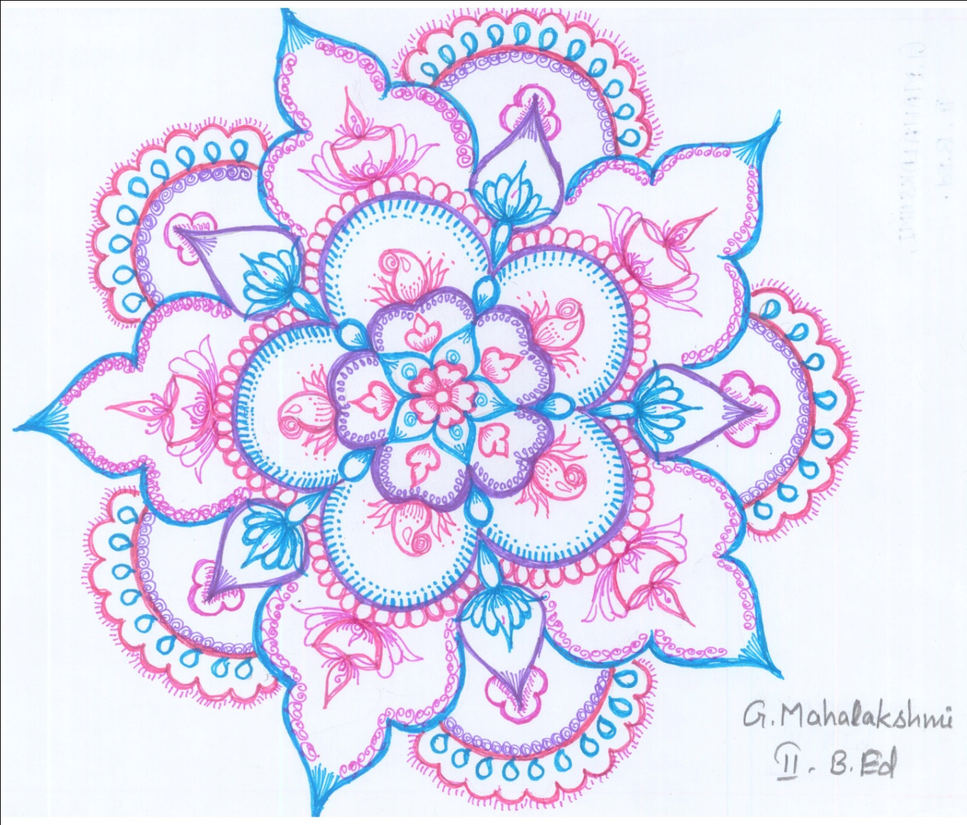
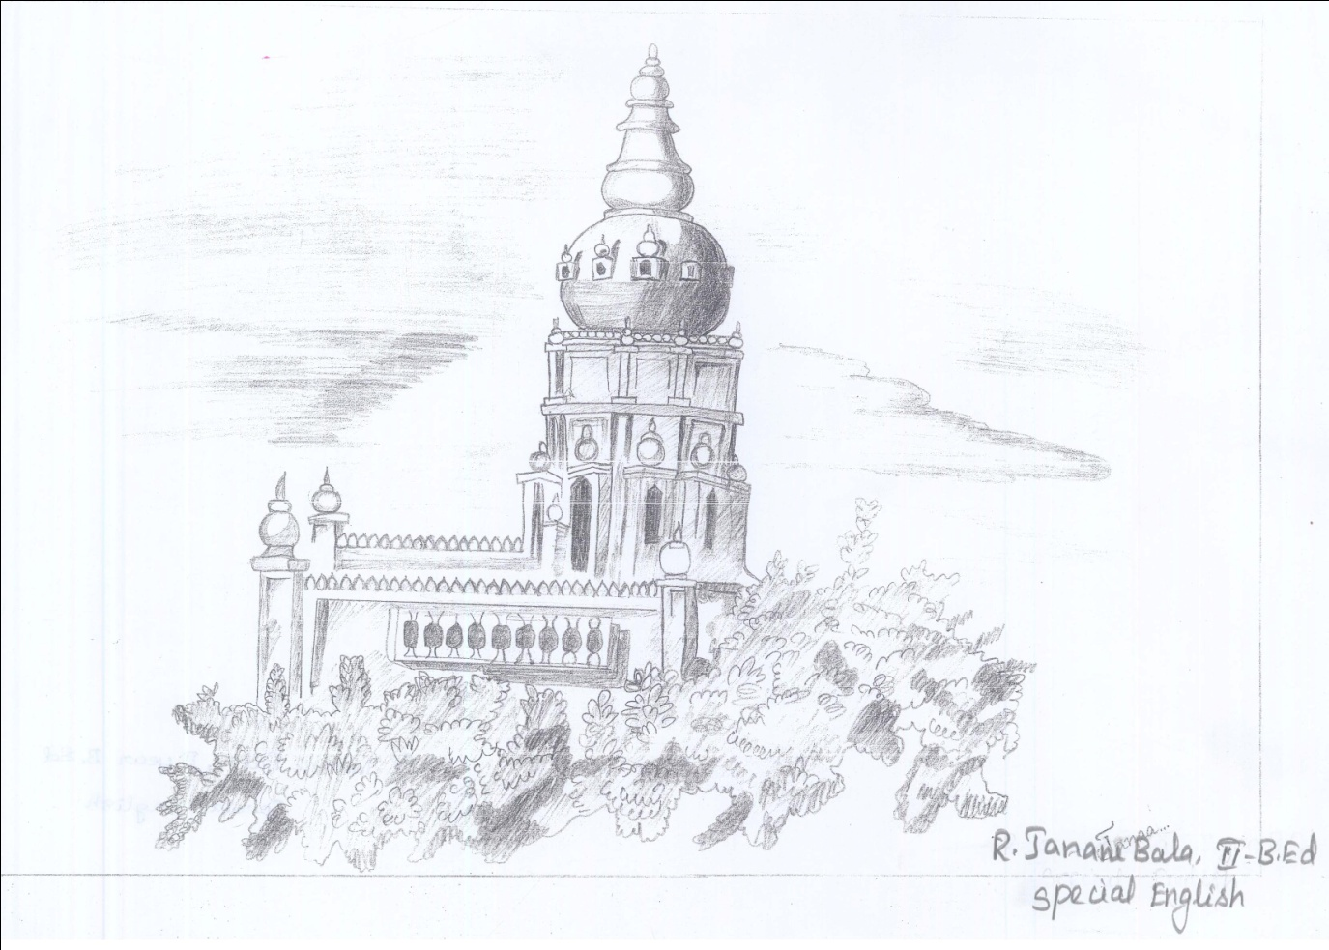
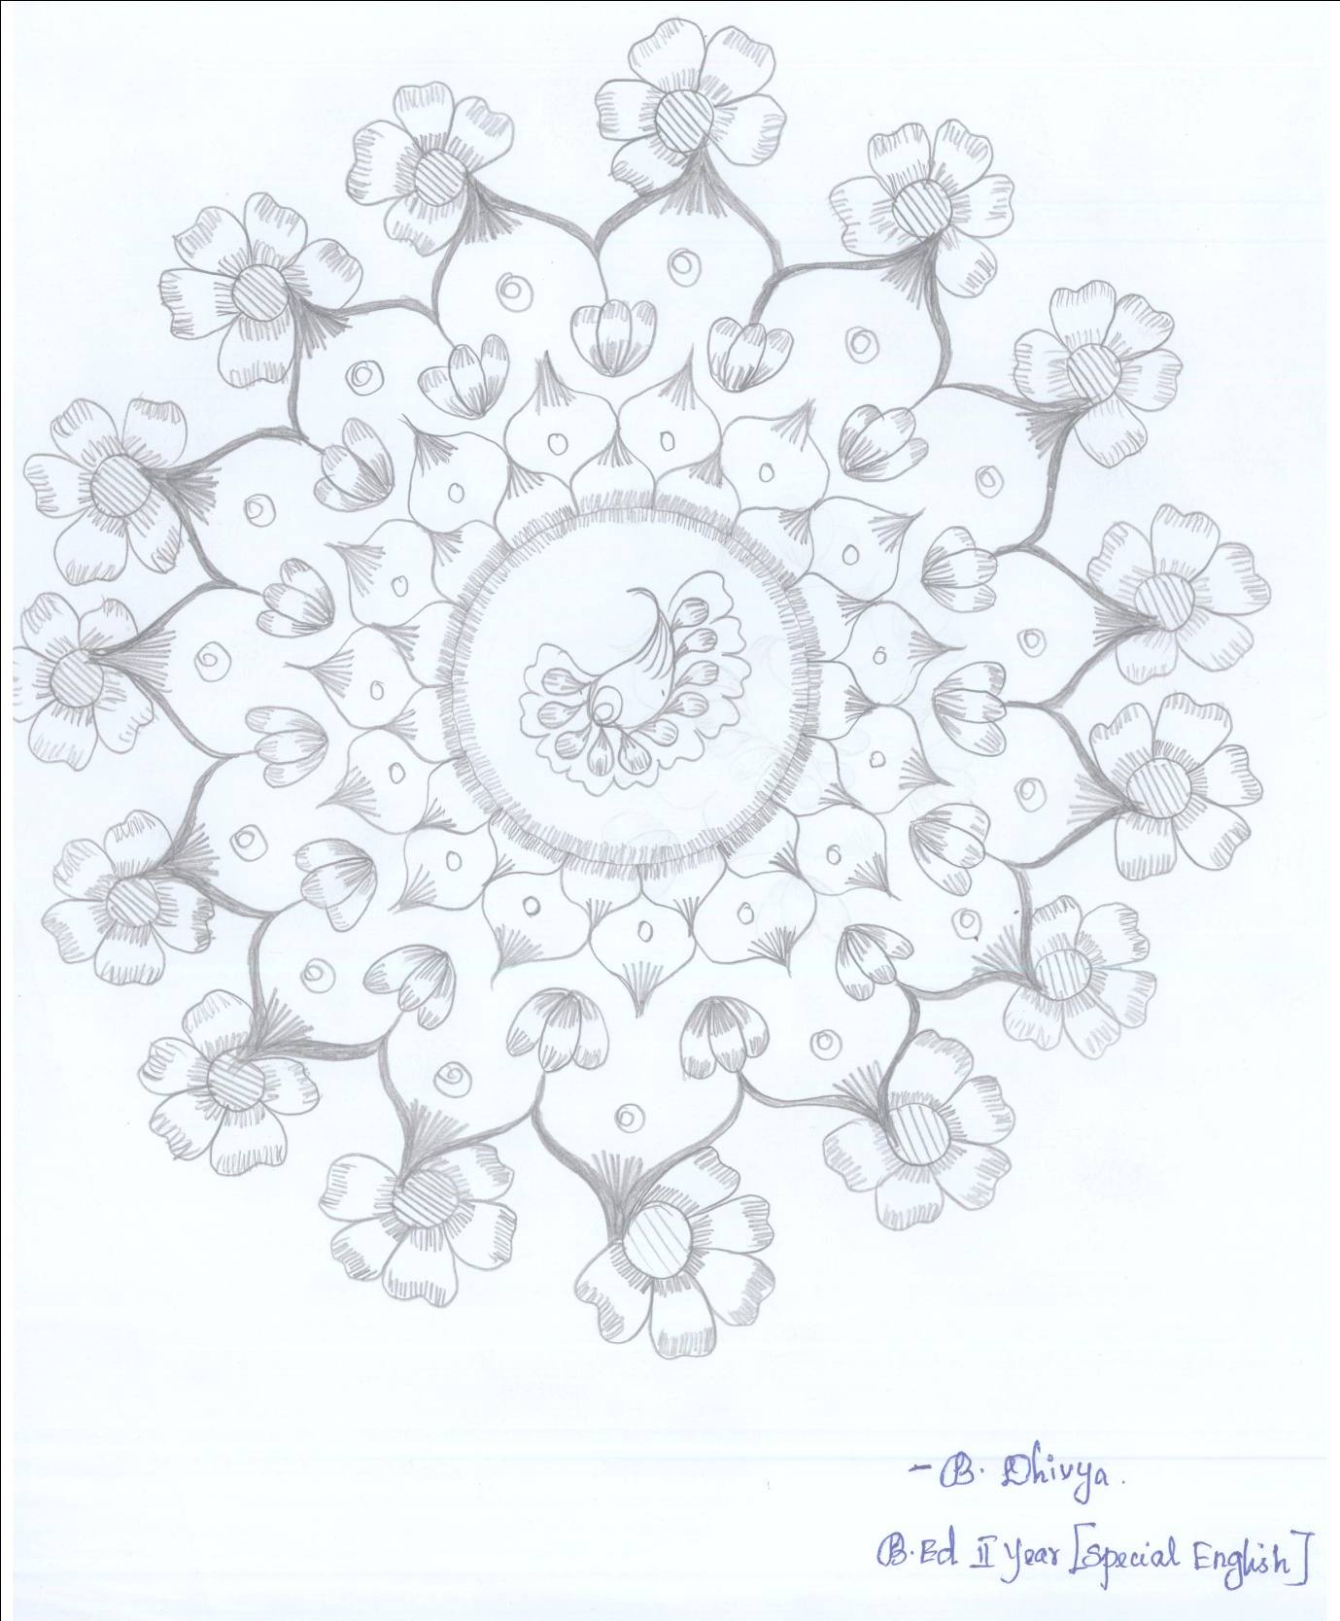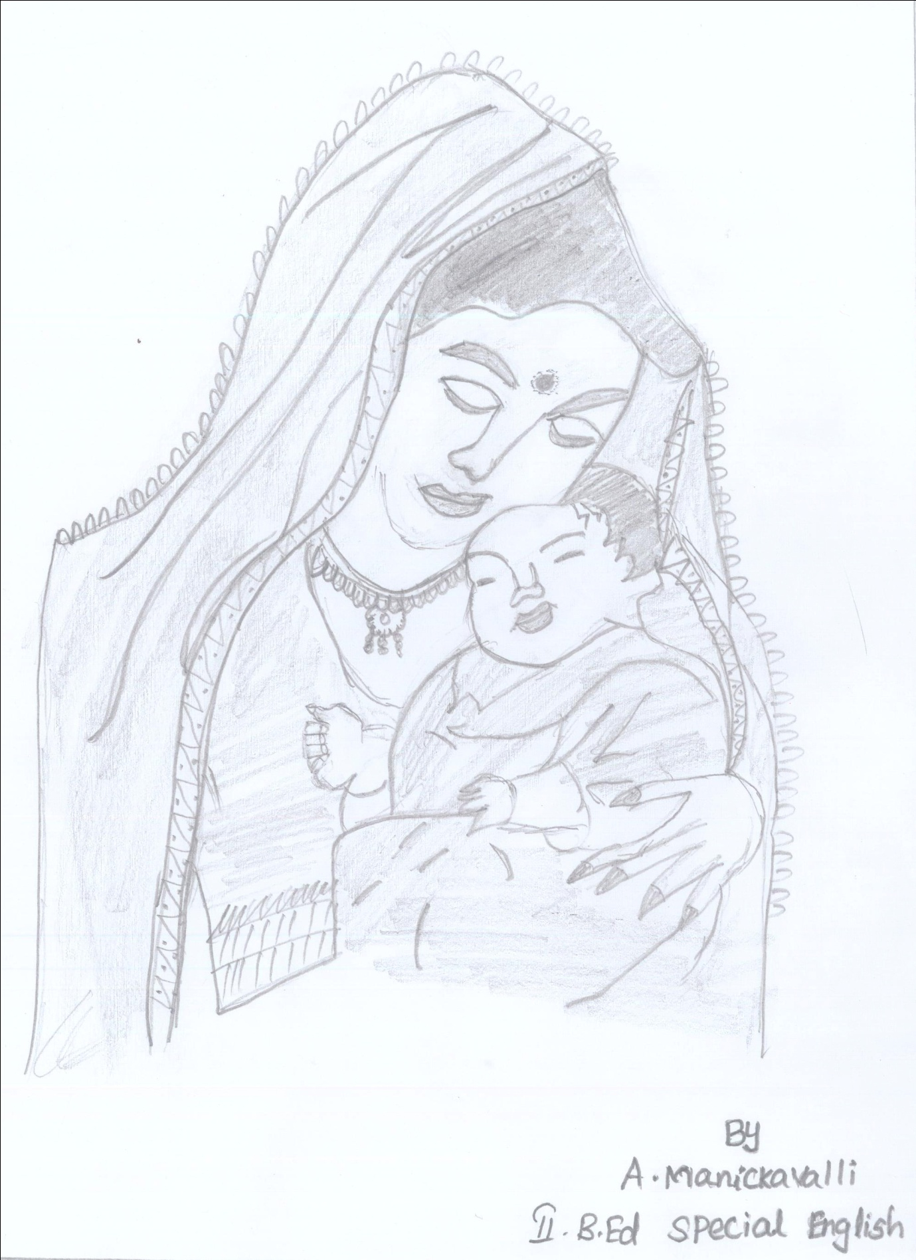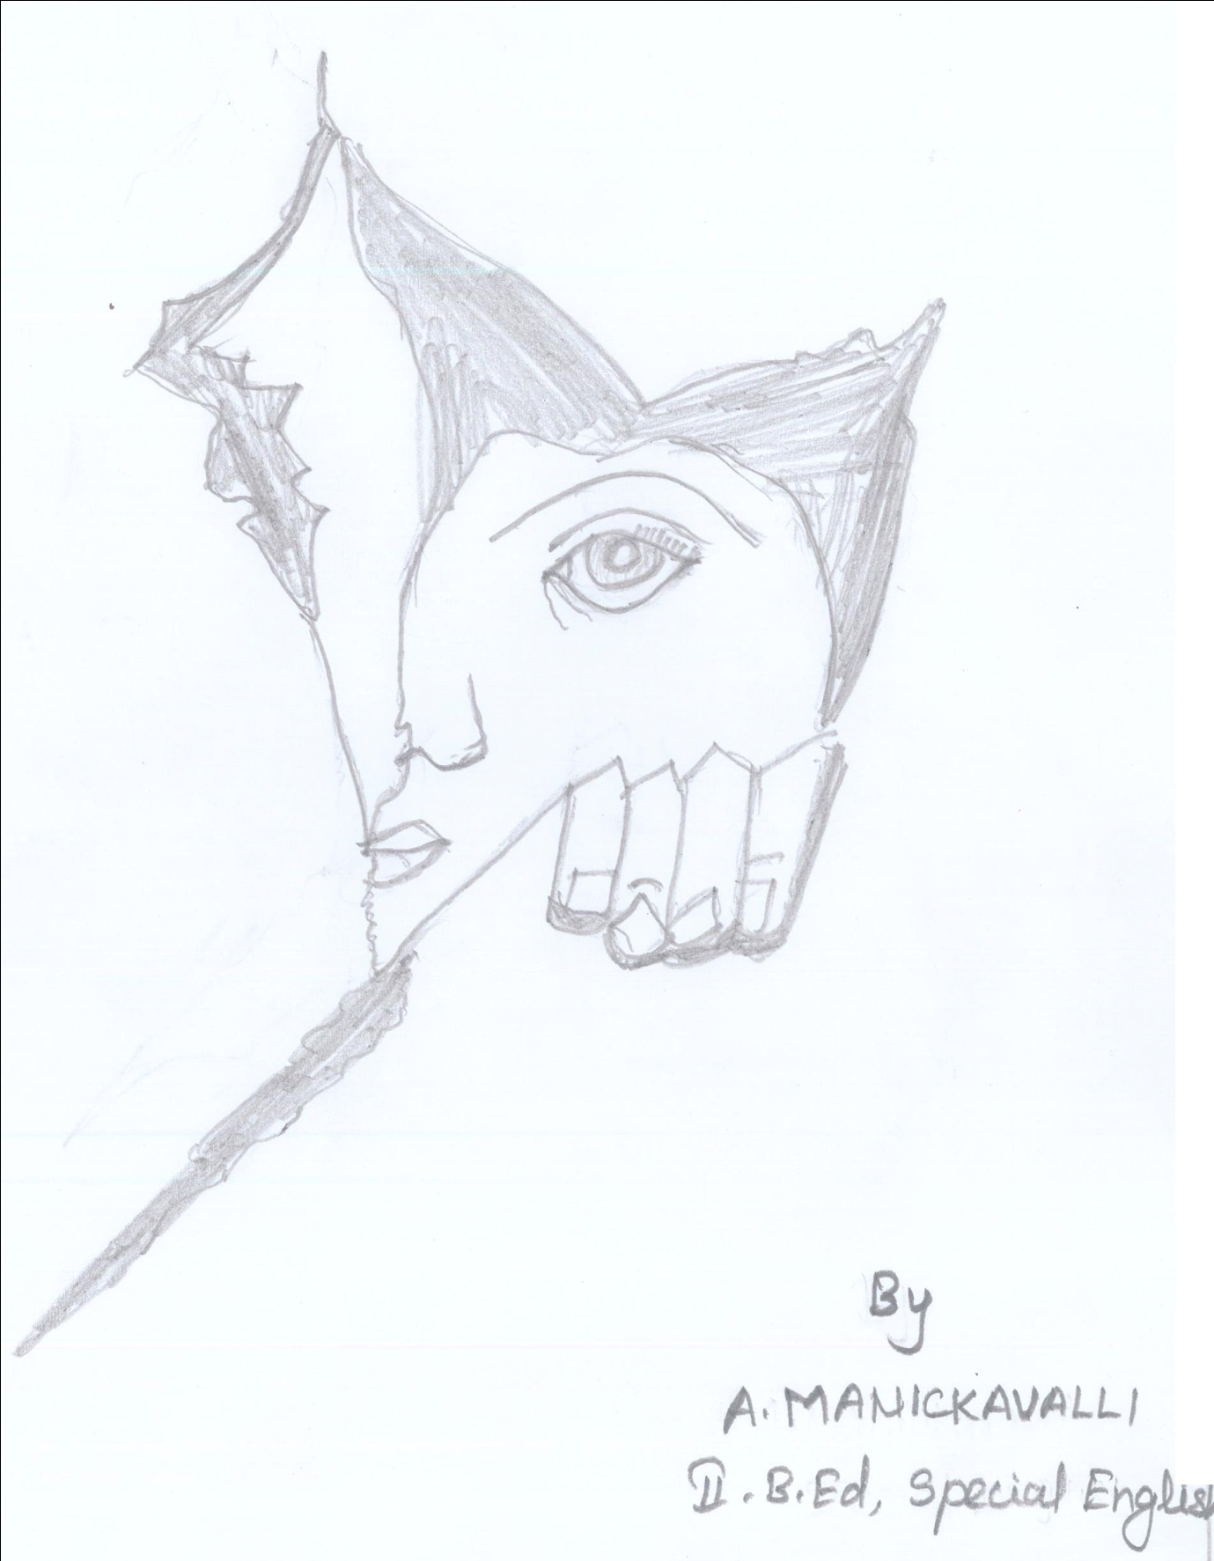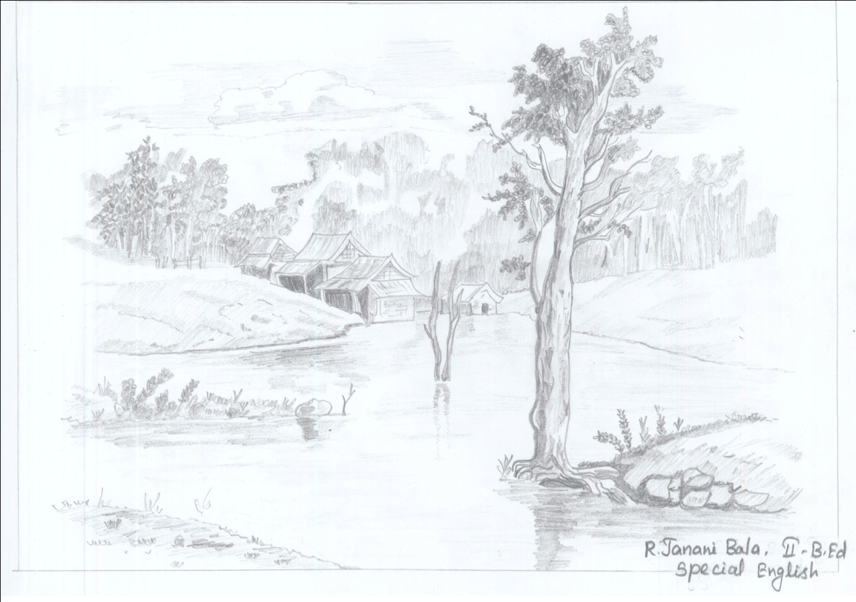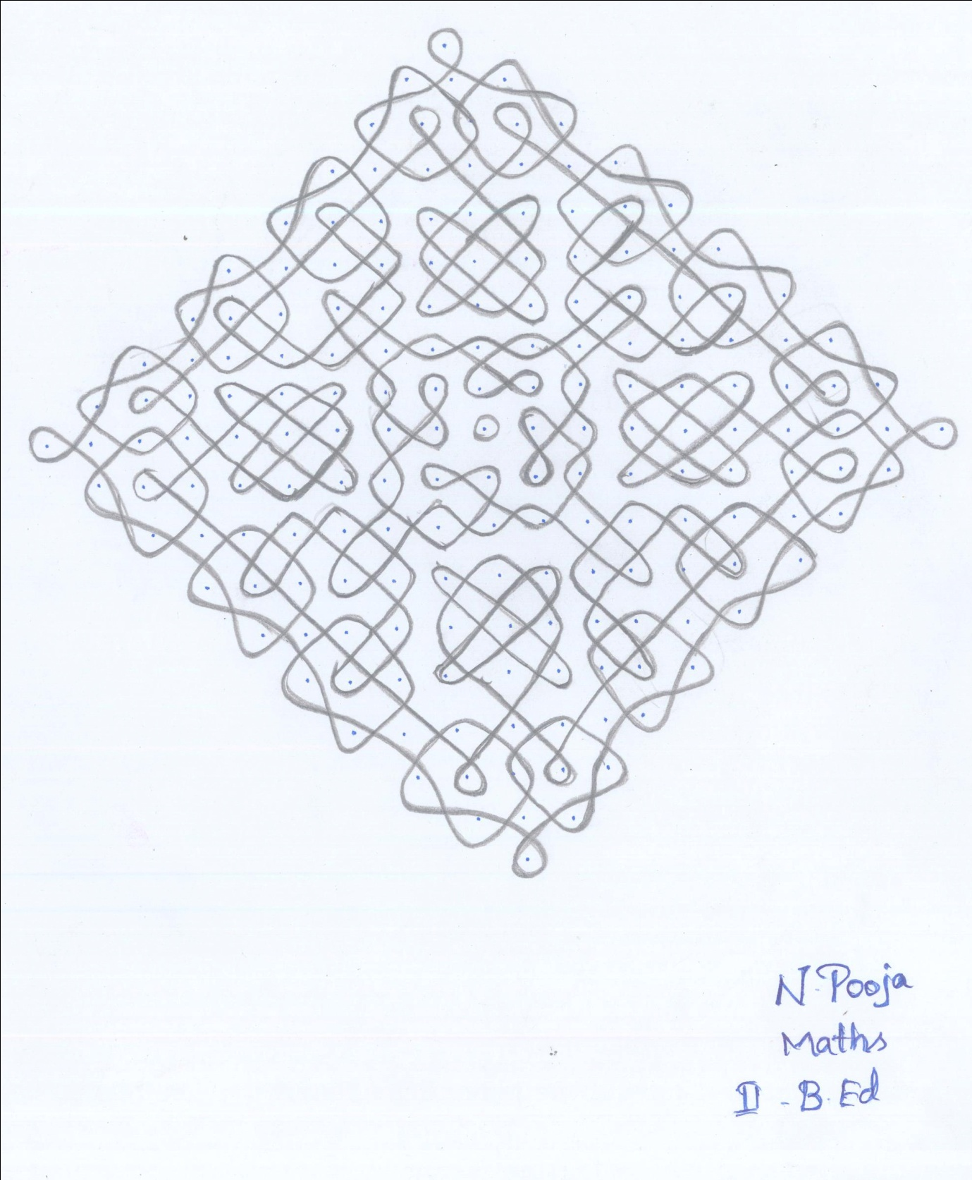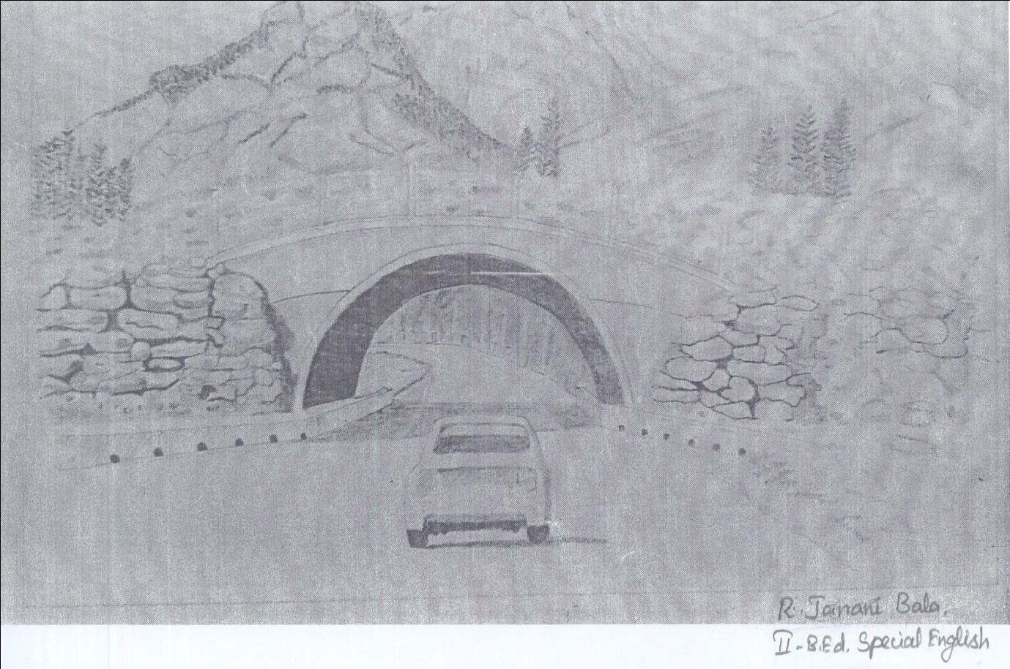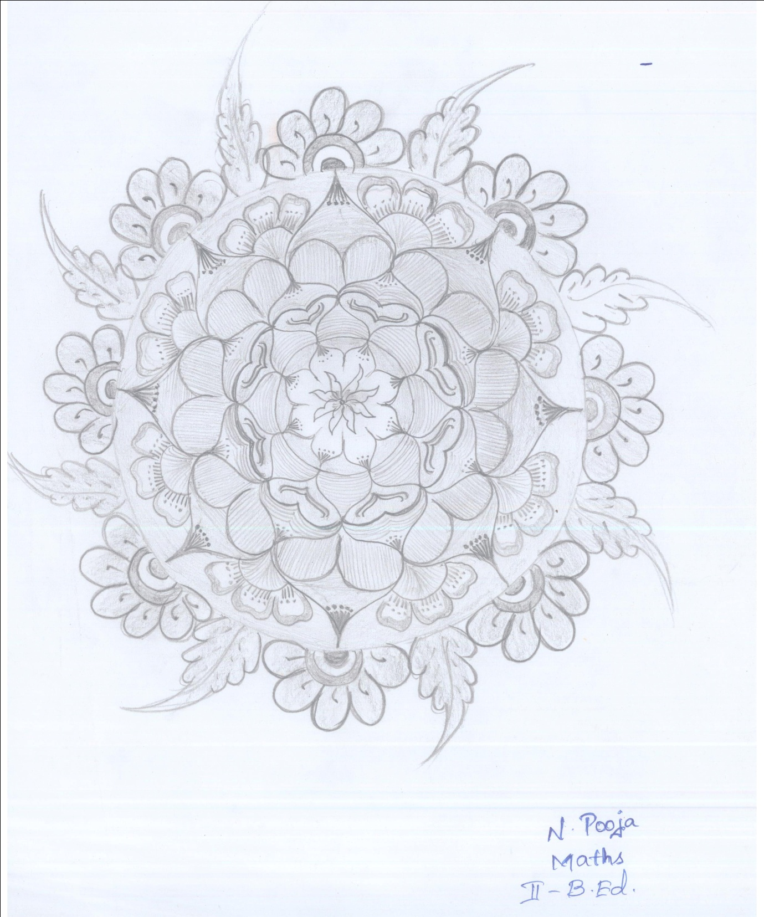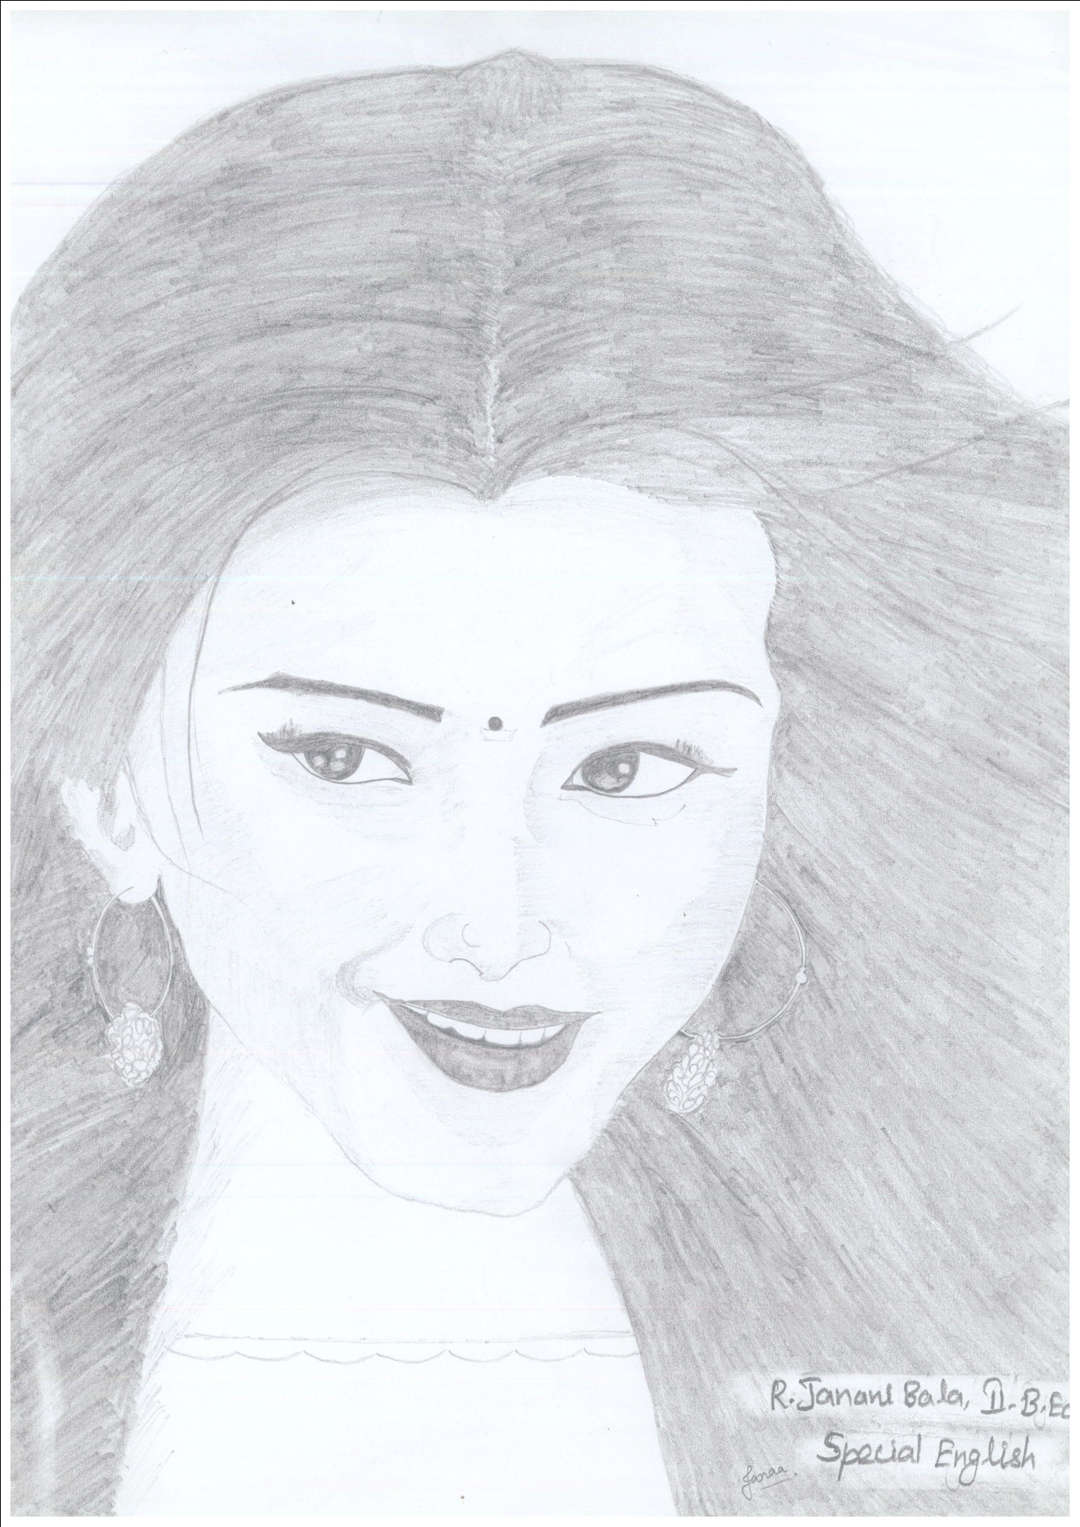
Photo Gallery
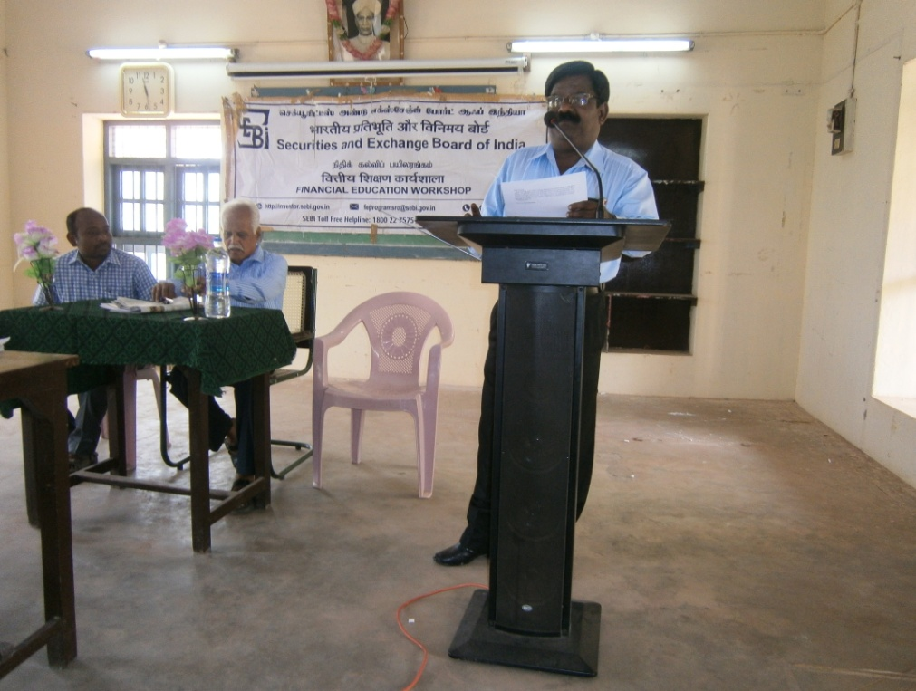
FINANCIAL EDUCATION WORKSHOP
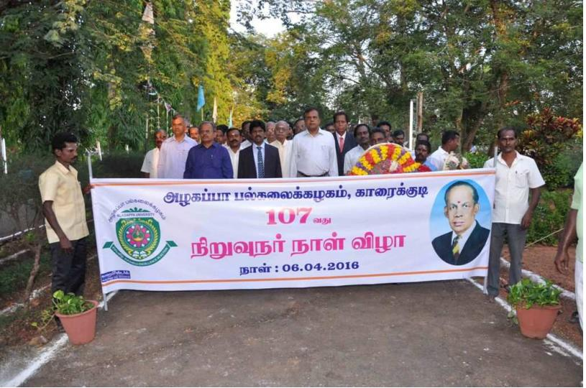
FOUDER'S DAY CELEBRATION

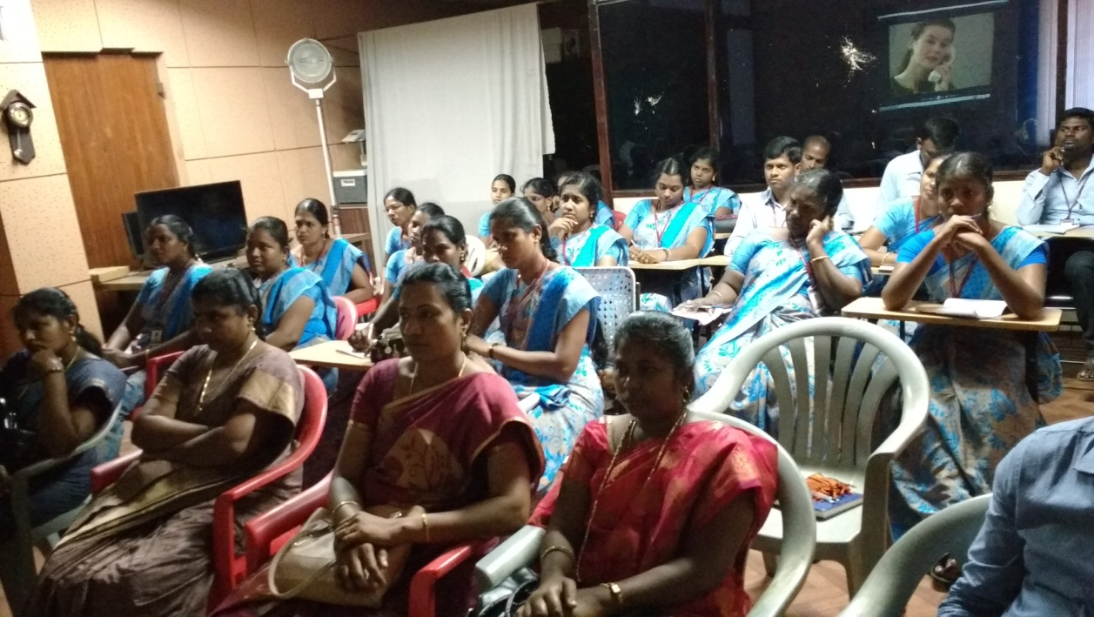
INSTITUTIONAL VISIT TO BHARATHIDASAN UNIVERSITY
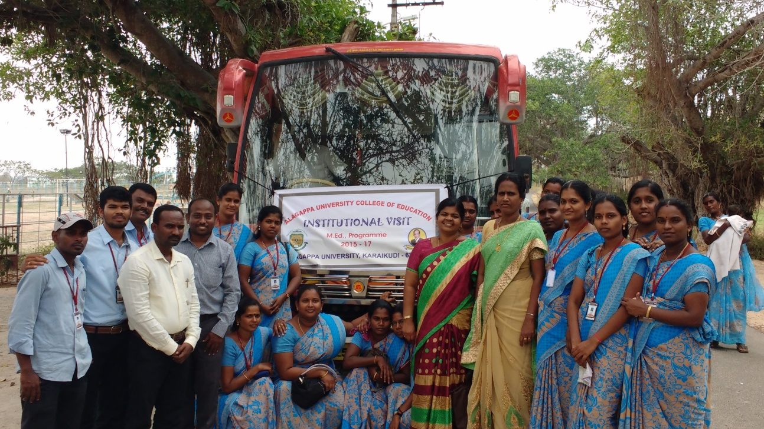
INSTITUTIONAL VISIT TO DIET, PUDUKOTTAI (2)
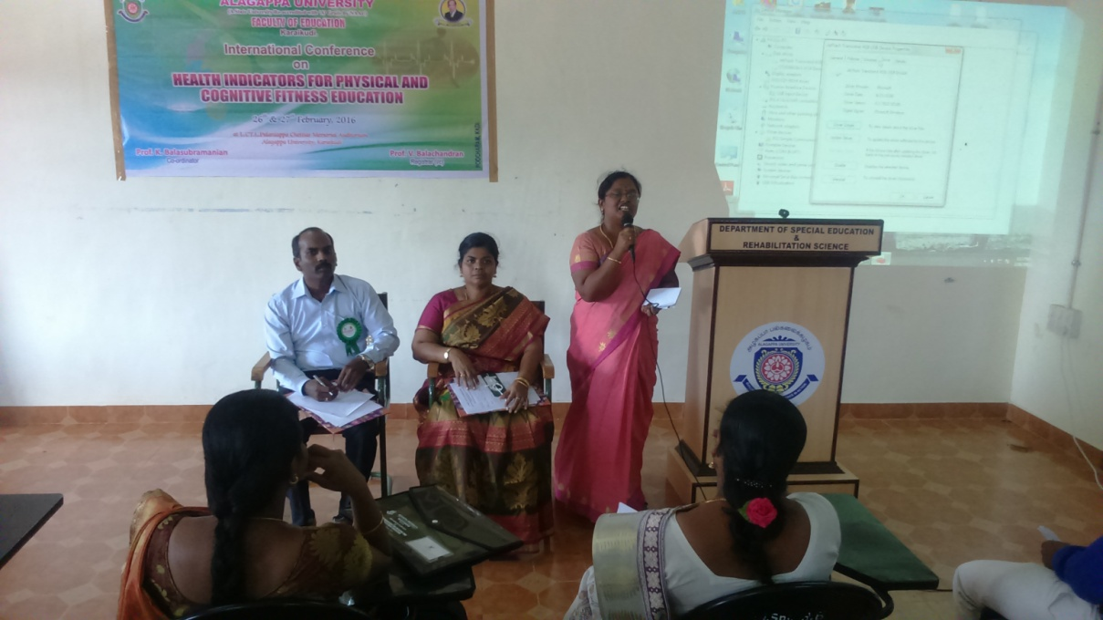
INTERNATIONAL CONFERENCE ON HEALTH CONDITION INDICATORS & COGNITIVE FITNESS EDUCATION
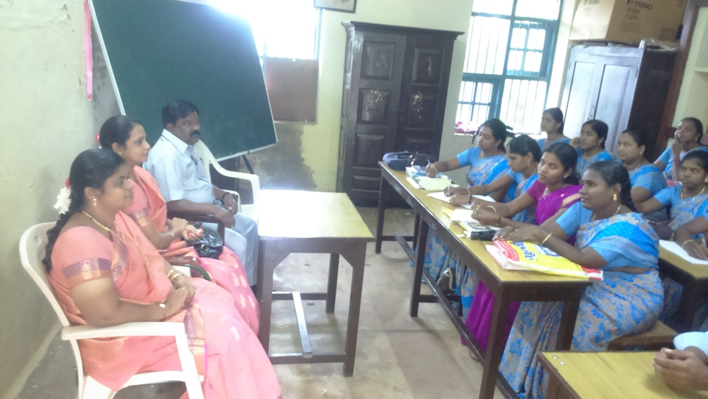
RESEARCH COLLOQUIM FOR M.ED STUDENTS
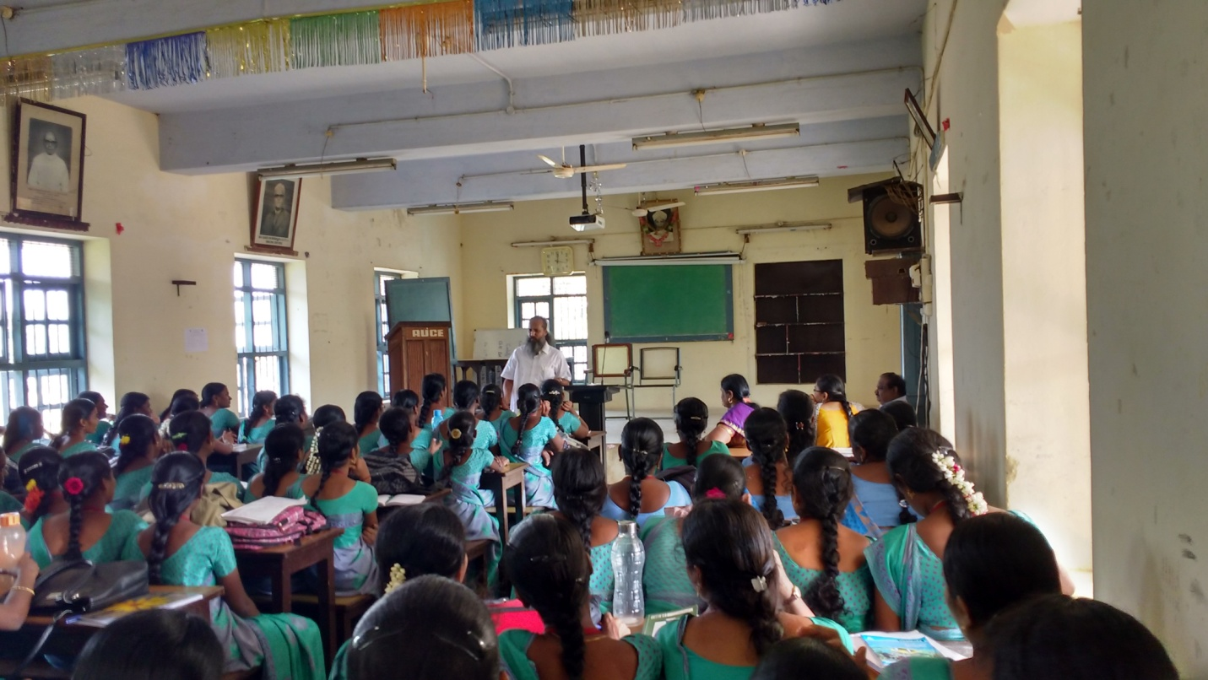
YOGA AWARENESS DAY CELEBRATION
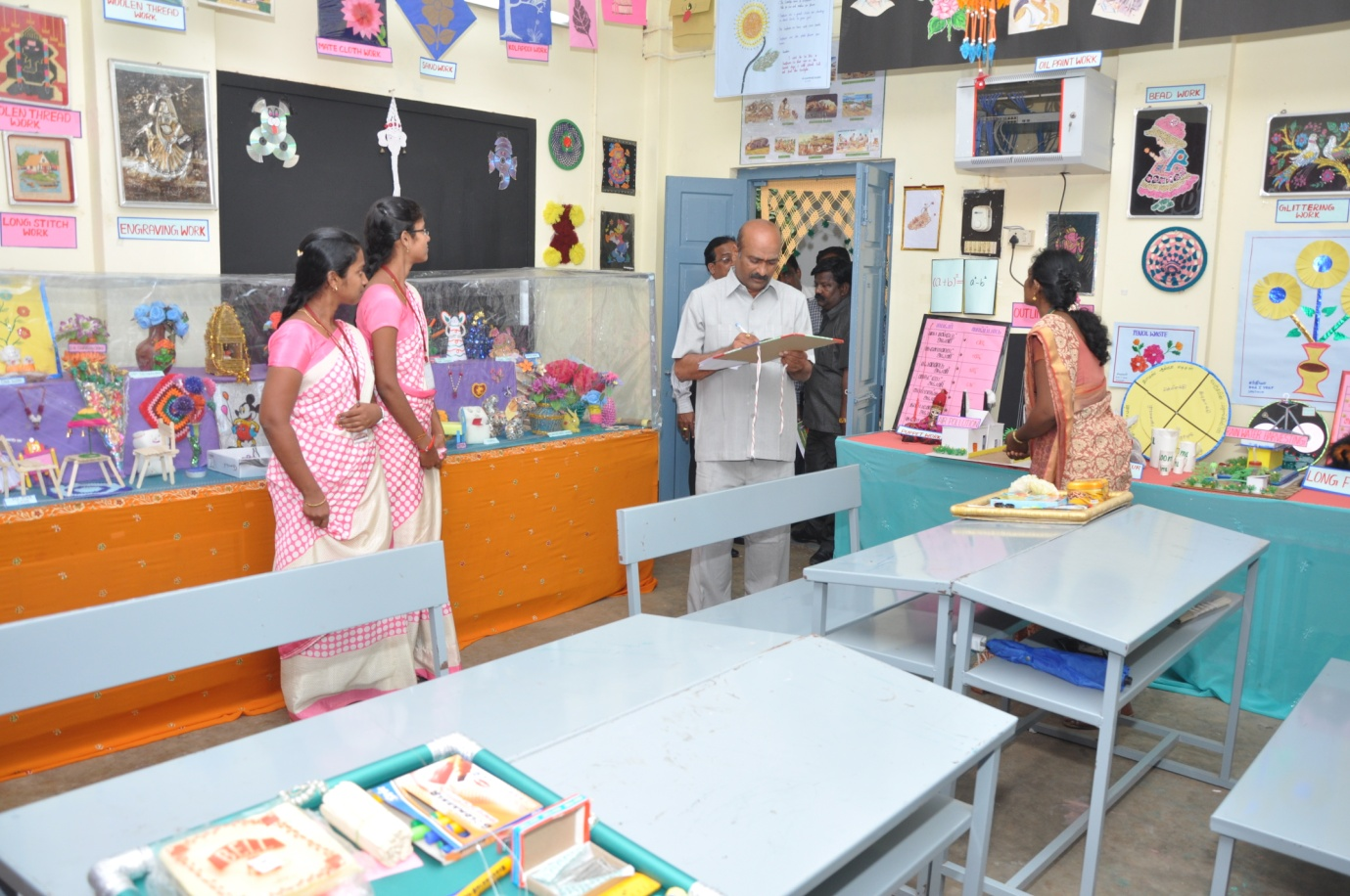
DISPLAY OF TEACHING - LEARNING MATERIALS AND HANDICRAFTS

